The Impact of Baseline Incidence Rates on Burden of Disease Assessment of Air Pollution and Onset Childhood Asthma: Analysis of Data from the Contiguous United States

**Haneen Khreis1, 2, 3, 4 *, Raed Alotaibi1,5,6 and Jennifer Horney7**

1 Center for Advancing Research in Transportation, Emissions, Energy, and Health (CARTEEH), Texas A&M Transportation Institute (TTI), Texas, USA

2 ISGlobal, Centre for Research in Environmental Epidemiology (CREAL), Barcelona, Spain

3 Universitat Pompeu Fabra (UPF), Barcelona, Spain

4 CIBER Epidemiologia y Salud Publica (CIBERESP), Madrid, Spain

5 Department of Family and Community Medicine, Imam Abdulrahman Bin Faisal University, Saudi Arabia

6 Texas A&M Health Science Center School of Public Health, Texas, USA

7 University of Delaware

**\* Corresponding author at Center for Advancing Research in Transportation Emissions, Energy, and Health (CARTEEH), Texas A&M Transportation Institute (TTI), 1111 RELLIS Parkway, Room 3412, Bryan, Texas 77807, USA.**

**Abbreviations**

**AC:** Attributable number of cases

**ACBS:** Asthma Call Back Survey

**AF:** Attributable fraction of cases

**BRFSS:** Behavioral Risk factor Surveillance System

**CDC:** Center for Disease Control and Prevention

**CRF**: Concentration-Response Function

**D.C.:** District of Columbia

**EPA:** United States Environmental Protection Agency

**U.S.:** United States

**LUR:** Land use regression

**NHGIS:** National Historical Geographic Information System

**PAF:** Population attributable fraction

**IR:** Incidence rate

**PV:** Prevalence rate

**TRAP:** Traffic-related air pollution

**Introduction**

Burden of disease assessment (BoD) is a powerful and relatively practical method to estimate the number/percentage of premature mortality and morbidity cases which may be attributable to environmental exposures. Such estimates can indicate how many cases of premature deaths and/or disease may be prevented by eliminating or reducing the exposure of interest. In the context of air pollution exposure, BoD methods have become increasingly popular and have been predominantly used to assess the burden of premature mortality which may be attributable to air pollution at the global, national, regional and local scales (Cohen et al., 2017, Cohen et al., 2005, Ostro and Organization, 2004, Lelieveld et al., 2015, Bhalla et al., 2014, Tainio, 2015, Mueller et al., 2017). The previous focus on mortality may reflect availability of well-established epidemiological data which associate air pollution with premature death but may also reflect the level of advancement in BoD, which is a relatively new practice still concerned with the most extreme outcome (death). Yet, to truly map, grasp and communicate to the true public health impact of air pollution exposures, extending BoD beyond premature mortality is required, especially to chronic health outcomes. Chronic outcomes are important as they have significant impacts on the quality of life of individuals and families, affect productivity at work and school, can result in death and imply significant health care costs which may be preventable. Further, given the ubiquity of air pollution exposure, especially in urban areas where it occurs near many people, the relatively modest-sized risk estimates from epidemiology translate into a large, yet modifiable, burden of disease.

One chronic health outcome which recently received more attention in the context of air pollution is the onset of childhood asthma. Asthma is a burdensome disease which is often cited as the most chronic illness of childhood (Gasana et al., 2012, National Survey of Children's Health, 2012), and is the third leading cause of hospitalization in children under the age of 15 and the leading cause of school absenteeism due to a chronic disease (American Lung Association, 2019, Hsu et al., 2016). In the United States (U.S.) alone, 6 million children had ongoing asthma in 2016 (Zahran et al., 2018). The economic burden of asthma on the U.S., including costs incurred by absenteeism and mortality, was $81.9 billion in 2013 (Nurmagambetov et al., 2018). In 2008 alone, there was an estimated 10.4 million missed school days for children with asthma, which also led to missed work days among children's caregivers (CDC, 2010).

There is emerging evidence that the exposure to air pollution, primarily when traffic-related, is associated with the onset of children’s asthma (Khreis et al., 2017), and more recent studies reconfirm these associations (Rancière et al., 2016, Rice et al., 2018, Lee et al., 2018, Pennington et al., 2018). A limited number of studies investigated the burden of childhood asthma onset which may be attributable to air pollution, building on this emerging evidence base which established positive and statistically significant associations between the risk of childhood asthma onset and increased exposures to traffic-related air pollution (TRAP). All previous BoD studies investigating this issue (Achakulwisut et al., 2019, Khreis et al., 2018b, Perez et al., 2009, Perez et al., 2013, Khreis et al., 2018a, Alotaibi et al., 2019) agreeably highlighted several data gaps which might impact the final BoD estimates and introduce uncertainty and error. These gaps are in fact applicable to BoD studies of air pollution and *any* health outcome. In summary, the accuracy of the BoD estimate are dependent on accuracy if the input data, namely: 1) the air pollution exposure levels and distribution, 2) the exposure-response functions, and 3) the baseline asthma incidence rates that are used. Some of the studies cited above have investigated the impacts of different input datasets on final BoD estimates and found that different exposure assessment methods (dispersion versus land use regression modeling) may result in up to % different BoD estimates. Similarly, we recently explored the impact of the exposure-response functions on the final burden of disease estimate and found that using the most conservative ERF (the lower 95% CI) can reduce the estimated burden by up to when compared to the central estimate. On the other hand, using the most extreme ERF (the upper 95% CI) can increase the estimated burden by up to when compared to the central estimate. The impact of asthma baseline incidence rates, however, has not been studied yet, despite being cited as a potential key source of error in BoD studies, and despite childhood asthma being a very challenging disease to ascertain and diagnose. All previous literature has relied on country-based asthma incidence rates, which is indeed in line with practice by prominent institutions and studies such as the Global Burden of Disease analysis. We, however, wanted to explore the potential impact of using state-specific varying asthma incidence rates on the final burden of childhood asthma due to NO2 exposure and compare the change in burden estimates from those produced by Alotaibi et al. (2019) which used a country level asthma incidence rate, as is typically done in BoD studies (Achakulwisut et al., 2019, Khreis et al., 2018b, Perez et al., 2009, Perez et al., 2013, Khreis et al., 2018a). We also explored the trends in the BoD by socioeconomic status and urban versus rural status using this more granular incidence rate data to confirm (or otherwise) previous trends we observed in our past analysis. We selected NO2 as the exposure of interest, as more studies underline this pollutant’s EFR and as it has been commonly used in previous BoD studies. Furthermore, the selection of the pollutant in this instance is less relevant as our aim is to compare previous estimates with present ones, only by altering the baseline childhood asthma incidence rates.

**Methods**

*Study area and time point*

We analyzed data for the 49 states within the contiguous U.S. and the District of Columbia (D.C.) for the year 2010 at the census block level: the smallest geographical unit available. Population counts, urban or rural living location and annual NO2 concentrations were all available at the census block level. However, median household income was available at the census block group level, which is one level higher than the census block (US Census Bureau, 2010). Childhood asthma incidence rates were calculated at the state level. NO2 concentrations were not available for states outside the contiguous U.S. (Alaska, Hawaii and Puerto Rico), and hence these states were excluded from the analysis.

*Census data*

We included populated census blocks of the contiguous U.S. for the year 2010, as obtained from the National Historical Geographic Information System (NHGIS) website (Manson et al., 2018, US Census Bureau, 2010). Each block included information on the total population of children <18 years old, and whether the census block was designated as an urban or a rural block. Census-designated urban areas were defined by the census bureau using multiple criteria including total population thresholds, density, nonresidential urban land use (e.g. paved areas and airports), and distance to other urban developed areas (US Census Bureau, 2016). Census blocks are the basic geographical units of urban areas. Further, census-designated urban areas are classified into two subtypes; urban clusters or urbanized areas. Urban clusters have a population threshold of ≥2,500 and <50,000, while urbanized areas have a population threshold of ≥50,000 people. The median household income in the past 12 months using 2010 inflation adjusted dollars was divided into five categories consistent with two previous relevant publications: <$20,000, $20,000 to <$35,000, $35,000 to <$50,000, $50,000 to <$75,000 and ≥$75,000 (Clark et al., 2017, Alotaibi et al., 2019). Census blocks were assigned the same median household income of the census block group they resided within.

There were 2,686 (0.04%) census blocks with missing median household income data in 2010. These census blocks were assigned a “Not defined” status in the analysis of median household income. **Error! Reference source not found.** summarizes the geographical and demographic data across all census blocks included in this analysis.

Table 1: Census data description, year 2010

|  |  |  |
| --- | --- | --- |
| **Geographic characteristics** | **Total populated census blocks** | 6,182,882 |
| **Total census-designated urban areas** | 3,590,278 (58%) |
| **Demographic characteristics** | **Total population** | 306,675,006 |
| **Total population of children (birth – 18)** | 73,690,271 (24%) |
| **Mean (range) number of children in census blocks** | 12 (0-2214) |
| **Population of children by living location** | **Rural** | 13,763,183 (19%) |
| **Urban clusters (≥2,500 and <50,000 people)** | 6,994,464 (9%) |
| **Urbanized area (≥50,000 people)** | 52,932,624 (72%) |
| **Population of children by median household income** | **<$20,000** | 2,614,804 (4%) |
| **$20,000 to <$35,000** | 12,770,843 (17%) |
| **$35,000 to <$50,000** | 18,573,954 (25%) |
| **$50,000 to <$75,000** | 21,953,876 (30%) |
| **≥$75,000** | 17,763,239 (24%) |

*NO2 exposure assessment*

Annual average NO2 concentrations for each populated census block were available at the centroid location for the year 2010.

Concentrations were derived from a land use regression model (LUR) developed by Bechle et al. (2015). The model incorporates spatial and temporal air pollutant data. The spatial aspect is derived from the U.S. Environmental Protection Agency (EPA) air quality monitoring data, satellite data and several GIS covariates including impervious surfaces, elevation, major, minor and residential roads, and distance to cost. The temporal data is scaled using average monthly monitor readings for 11 consecutive years. The model achieves a relatively high predictive power using hold-out cross validation when compared to similar LUR models (Vienneau et al., 2013, Beelen et al., 2009, Hystad et al., 2011, Novotny et al., 2011) with an R2 reaching 82%. The LUR model has been used in multiple studies including (Clark et al., 2017, Alotaibi et al., 2019). A detailed description of the model can be found at Bechle et al. (2015). NO2 concentrations were converted from ppb to ug/m3through multiplying by 1.88 (WHO, 2005). Exposure data was matched with census blocks using a unique identifier for each census block as provided from the NHGIS dataset.

*Concentration-response functions*

We used an asthma development concentration-response function (CRF) of 1.05 (95% CI = 1.02-1.07) per 4 ug/m3 of NO2. The CRF was obtained from a meta-analysis of 20 studies examining the association between exposure to TRAP and the risk of developing asthma among children from birth to 18 years of age (Khreis et al., 2017). These CRF represent data from the most up-to-date and widest analysis on traffic-related air pollution and the onset of childhood asthma, and has been used in several published peer-reviewed BoD assessments (Khreis et al., 2018b, Khreis et al., 2018a, Achakulwisut et al., 2019, Alotaibi et al., 2019, Khreis, In prep).

*Asthma incidence and prevalence rate*

An incidence rate (IR) is defined as the number of new cases of a disease within a specified time period among an at-risk population (Mausner and Kramer, 1985). To estimate the aggregate childhood asthma IR for the years 2006 through 2010 among U.S. states, we obtained the Behavioral Risk Factor Surveillance System (BRFSS) and Asthma Call Back Survey (ACBS) (CDC, 2011, CDC, 2009) child data sets from the Center for Disease Control and Prevention (CDC) website <https://www.cdc.gov/brfss/> and followed methods described by Winer et al. (2012) and shown in **Error! Reference source not found.**. The following variables were extracted: the state, asthma status question (BRFSS), incident status question (ACBS), and children sample weights. All analysis was conducted using R statistical software (R Core Team, 2018). States and territories not within the contiguous U.S. were excluded from the analysis, namely Alaska, Hawaii and Puerto Rico.

Figure 1: Childhood asthma incidence rate estimation flow chart

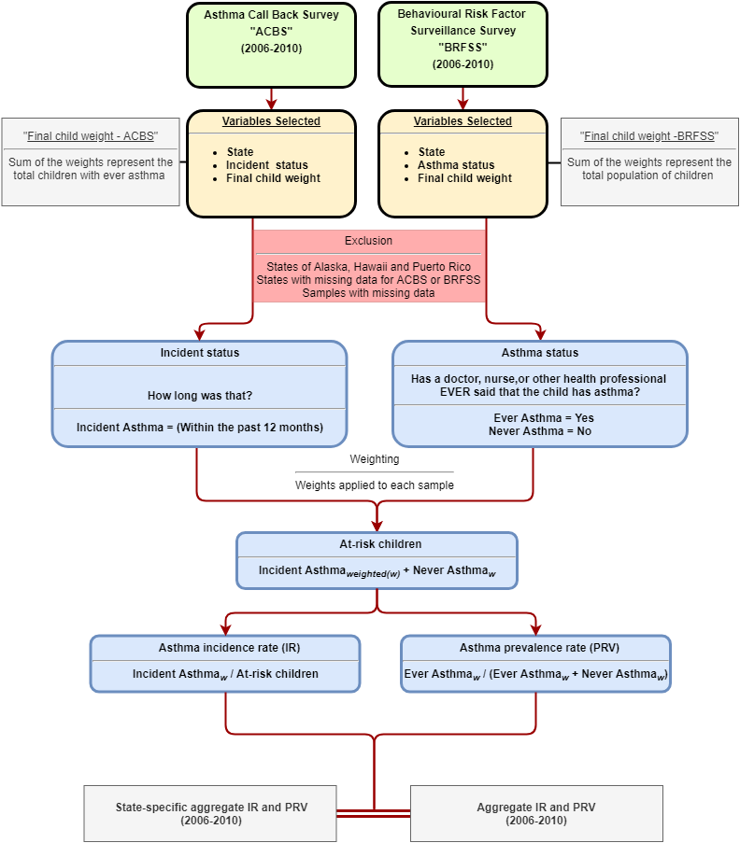

To determine the “Asthma status” of children, respondents to the BRFSS were asked “Has a doctor, nurse, or other health professional EVER said that the child has asthma?”, If the answer was “Yes”, the respondent was designated as “Ever asthma”. If the answer was “No”, the respondent was designated as “Never asthma”. Respondents with children designated as “Ever asthma” were requested to participate in the ACBS follow up. To determine the “Incident status” of children, respondents to the ACBS were asked: “How old was the [name of child] when a doctor or other health professional first said [he/she] had asthma? How long ago was that?” If the answer to the latter part of this question was “within the past 12 months”, the respondent was designated as an “Incident asthma”, while other responses were not relevant to the analysis described next.

Each respondent (sample) from the BRFSS and ACBS was assigned a weight to adjust for the disproportionate population sample selection as compared to the state’s overall population distribution, the variation in probability of selection, the actual response of each respondent, or nonresponse (Garbe et al., 2011, Korn and Graubard, 2011). The weight of each sample represents the number of children within each state, with similar characteristics to the sample. Weights were used to convert samples to population estimates of children. For example, if respondent (X) had a weight of 150, her/his response to survey questions represented answers of 150 children within their state. The sum of childhood weights for the BRFSS represent the total population of children within each state, while the sum of weights for the ACBS represent the total population of children with “Ever asthma” within each state.

“At-risk children” were then estimated by taking the weighted sum of respondents designated as “Incident asthma” and “Never asthma”, as shown in Equation 1.

$$At-risk children = {Incident asthma}_{weighted(w)}+ {Never asthma}_{w}$$

Equation 1

The asthma IR was the weighted “Incident asthma” divided by “At-risk children”, as shown in Equation 2.

$$Asthma incdence rate (IR)={Incident asthma}_{w} / At-risk children$$

Equation 2

The asthma prevalence rate (PR) was the weighted “Ever asthma” divided by the sum of weighted “Ever asthma” and weighted “Never asthma”, as shown in Equation 3.

$$Asthma prevalence rate (PR)={Ever asthma}_{w} / ({Ever asthma}_{w}+{Never asthma}_{w})$$

Equation 3

The asthma IR was then aggregated across the all available years by taking the sum of weighted “Incident asthma” divided by the sum of “At-risk children” for the years 2006 through 2010, as shown in Equation 4.

$$Aggregate IR=∑{Incident asthma}_{w} / ∑At-risk children$$

Equation 4

The aggregate asthma PR across all the states during the same time period was estimated as shown in Equation 5.

$$Aggregate PR={∑Ever asthma}_{w} / ({∑Ever asthma}_{w}+{∑Never asthma}_{w})$$

Equation 5

To obtain the state-specific asthma incidence rates we used the above equations for each state. States that did not participate and/or states that did not have available data in the ACBS during the period 2006 through 2010 (n = 19 states) were assigned the aggregate asthma incidence () and prevalence rates () (Table S2).

*Burden of disease estimation*

To estimate the burden of disease, we followed the methods described in Alotaibi et al. (2019) with the following steps:

The total number of at-risk children residing in a census block was estimated for each state by subtracting the total number of children within the census block multiplied by the state-specific PR from the total number of children within the same census block, as shown in Equation 6.

$${At-risk children}_{census block\left(c\right)}={Total children}_{c}-({Total children}_{c}*{Aggregate PR}_{State(s)})$$

Equation 6

We then estimated the number of childhood asthma incident cases within each census block by multiplying the state-specific aggregate childhood asthma IR by the at-risk children at the census block level, as shown in Equation 7.

$${Asthma incident cases}_{c}={At-risk children }_{c}*{Aggregaget IR}_{s}$$

Equation 7

We then calculated the relative risk (RRdiff) for asthma onset due to the exposure difference between the estimated exposure levels from the LUR model (NO2 concentration at the census block level) and no exposure (zero concentration for NO2), as shown in Equation 8.

$${RR}_{diff}=e^{((\ln\left(RR\right) {/ RR}_{unit} * {Exposure}_{c})}$$

Equation 8

Where RR is the CRF and RRunit is the exposure unit (4 ug/m3) for the CRF as extracted from Khreis et al. (2017). The population attributable fraction (PAF) was then estimated using Equation 9:

$${PAF}_{c}=\left({RR}_{diff}-1\right)/ {RR}_{diff}$$

Equation 9

The attributable number of asthma incident cases (AC) was estimated by multiplying the PAF with the total number of incident asthma cases at each census block (Equation 7), as shown in Equation 10.

$${AC}_{c}={PAF}_{c}*{Asthma incident cases}_{c}$$

Equation 10

The attributable number of asthma incident cases for each census block was then summed across the state, and the entire country, to get the total AC, as shown in Equation 11.

$$Total AC=∑{AC}_{c, s}$$

Equation 11

**Results**

*NO2 concentrations and trends*

The mean (min-max) NO2 concentrations were 13.3 (1.5-58.3) ug/m3 (**Error! Reference source not found.**). By living location, the mean NO2 concentration was highest in urbanized areas (18.4 ug/m3) (Figure S1), while the mean NO2 concentration was highest among the highest median household income group of ≥$75,000 (16.5 ug/m3) followed by the lowest median household income group of <$20,000 (16.5 ug/m3) (Figure S2). When stratifying NO2 concentrations by median household income groups but separately for each living location, rural areas had an increasing average concentration as income increased, urban clusters has a decreasing average concentration as income increased while urbanized areas showed a U-shaped trend (Figure S3 and Figure S4). South Dakota had the lowest mean NO2 concentration (5.2 ug/m3), while the District of Columbia had the highest (26.3 ug/m3) (Table S1 and Figure S5). Figure S6 and Figure S7 demonstrate NO2 concentrations across median household income and living location, separately for each state.

Table 2: NO2 concentrations (ug/m3) by strata

|  |  |  |  |  |  |  |  |
| --- | --- | --- | --- | --- | --- | --- | --- |
|  |  | **Mean** | **Min** | **25%** | **Median** | **75%** | **Max** |
| **Total** |  | 13.2 | 1.5 | 7.9 | 11.4 | 16.6 | 58.3 |
| **By living location** | **Rural** | 8.0 | 1.5 | 6.0 | 7.8 | 9.8 | 37.7 |
| **Urban cluster** | 12.0 | 1.6 | 9.6 | 11.9 | 14.2 | 35.6 |
| **Urbanized area** | 18.4 | 2.6 | 13.0 | 17.0 | 22.1 | 58.3 |
| **By median household income** | **<$20,000** | 16.1 | 2.0 | 10.4 | 14.9 | 20.1 | 56.8 |
| **$20,000 to <$35,000** | 13.2 | 1.6 | 8.1 | 11.7 | 16.7 | 58.3 |
| **$35,000 to <$50,000** | 11.8 | 1.5 | 7.0 | 10.0 | 14.5 | 58.0 |
| **$50,000 to <$75,000** | 12.8 | 1.6 | 7.6 | 10.8 | 15.7 | 55.7 |
| **≥$75,000** | 16.5 | 2.1 | 10.9 | 14.9 | 20.6 | 55.5 |

*ACBS and BRFSS results*

Overall, there were 32 states with available childhood asthma incidence rates (**Error! Reference source not found.** and Table S3). The total childhood samples included for the period 2006-2010 were 293,464 samples from the BRFSS and 16,156 samples from the ACBS. The BRFSS samples for each year ranged between 55,094 samples in 2006 and 61,862 in 2008. The ACBS samples for each year ranged between 2,016 samples in 2006 and 4,095 in 2009. The weighted estimates represent the childhood population counts of available states from the BRFSS and the ACBS, for the years when the survey was conducted.

Across all participating states, the overall aggregate asthma incidence rate for the years 2006-2010 was 12.1 per 1,000 at-risk children. The state of Montana had the lowest aggregate childhood asthma incidence rate (IR = 4.3 per 1,000 at-risk children), while District of Columbia had the highest aggregate childhood asthma incidence rate (IR = 17.7 per 1,000 at-risk children). States that did not have an incidence rate available (16 states) were assigned the overall aggregate asthma incidence rate of 12.1 per 1,000 at-risk children (Table S2).

Table 3: Childhood asthma survey summaries

|  |  |  |  |  |  |  |
| --- | --- | --- | --- | --- | --- | --- |
|  | **2006** | **2007** | **2008** | **2009** | **2010** | **Total** |
| **BRFSS sample (weighted)** | 55,094 (50,674,742) | 59,487 (43,661,381) | 61,862 (53,327,550) | 59,821 (47,747,373) | 57,200 (39,975,264) | 293,464 |
| **Ever asthma sample (weighted)** | 7,168 (6,493,224) | 7,971 (5,763,409) | 8,255 (7,218,400) | 8,126 (6,279,938) | 7,483 (5,158,455) | 39,003 |
| **ACBS Sample (weighted)** | 2,017 (4,580,870) | 2,797 (5,459,638) | 3,924 (4,343,245) | 4,095 (4,154,076) | 2,196 (3,116,669) | 16,156 |
| **Incident case sample (weighted)** | 154 (404,276) | 173 (312,917) | 169 (385,818) | 153 (297,546) | 160 (319,743) | 809 |
| **At-risk sample (weighted)** | 48,080 (30,825,589) | 51,689 (36,050,557) | 53,776 (26,491,259) | 51,848 (25,942,087) | 49,877 (22,900,850) | 255,270 |
| **Incidence rate** | 13.1 | 8.7 | 14.6 | 11.5 | 14.0 | 12.1* |
| **Prevalence rate** | 12.8 | 13.2 | 13.5 | 13.2 | 12.9 | 13.1** |
| **Number of states included** | 18 | 26 | 20 | 17 | 17 | 32*** |

*\*Aggregate asthma incidence rate per 1,000 at-risk children*

*\*\*Aggregate asthma prevalence rate per 100 children*

*\*\*Total number of states included in the aggregate asthma incidence rate estimation*

*Asthma incident cases*

Using state-specific asthma incidence rates, the estimated number of childhood asthma incident cases were 754,893 in 2010 (Table 4). By living location, 19% lived in a rural area, while 9% and 72% lived in an urban cluster and urbanized area, respectively. The largest percentage of childhood asthma cases (28%) lived in an income block group of $50,000 to <$75,000, while the lowest percentage (4%) lived in the lowest income block group of <$20,000. The state with the lowest number of estimated childhood asthma incident cases was Montana with 900 cases, while the state with the largest number was Texas with 99,100 cases (Table S4).

*Attributable number of cases and fraction*

On average, we estimated a total of 132,829 childhood asthma cases attributable to NO2 exposure which accounted for 17.6% of all childhood asthma cases (Table 4). By living location, urbanized areas had the largest number of attributable cases totaling 109,581 cases and the highest percentage of all asthma cases at 20.3%. Rural areas had total of 13,951 cases and accounted for the least percentage of all asthma cases at 9.8%, while urban clusters had only 9,296 cases representing 13% of all asthma cases (Table 4 and Figure S8). By income, $50,000 to <$75,000 had the largest number of cases attributable to NO2: 37,559 cases accounting for 16.8% of all asthma cases. However, the income group with the largest percentage of asthma cases attributable to NO2 exposure was the lowest income group <$20,000, accounting for 20.8% of all asthma cases (Figure S9). The mean value of the attributable fraction increased by income group in rural areas, decreased by income group in urban clusters and presented as a U shape in urbanized areas (Figure 2 and Figure S10).

The state with the lowest number of estimated attributable cases was Montana with 70 cases, while the state with the largest number of estimated attributable cases was California with 19,200 cases. The state with the lowest attributable fraction was South Dakota (7.6%), while the state with the highest attributable fraction was District of Columbia (26.9%) (Figure 3 and Table S4 ).

Table 4: Comparing results of the burden of disease using state-specific estimates vs original estimates

|  |  |  |  |  |  |  |  |  |  |  |  |  |  |  |  |  |
| --- | --- | --- | --- | --- | --- | --- | --- | --- | --- | --- | --- | --- | --- | --- | --- | --- |
|  |  | **Main results using state-specific IR** | | | | **Original results using flat national-level IR** | | | | **Difference** | | | | **Percentage difference** | | |
|  |  | **Incident cases** | **AC** | **AF** | **Incident cases** | | **AC** | **AF** | **Incident cases** | | **AC** | **AF** | **Incident cases** | | **AC** | **AF** |
|  | **Total** | 754,893 | 132,829 | 17.6% | 794,934 | | 141,931 | 17.9% | -40,041 | | -9,103 | -0.3% | -5.0% | | -6.4% | -1.4% |
| **By living location (% of Total)** | **Rural** | 142,559 (19%) | 13,951 (11%) | 9.8% | 148,470 (19%) | | 14,466 (10%) | 9.7% | -5,911 | | -514 | 0.0% | -4.0% | | -3.6% | 0.4% |
| **Urban cluster** | 71,249 (9%) | 9,296 (7%) | 13.0% | 75,453 (9%) | | 9,844 (7%) | 13.0% | -4,204 | | -549 | 0.0% | -5.6% | | -5.6% | 0.0% |
| **Urbanized area** | 541,085 (72%) | 109,581 (82%) | 20.3% | 571,011 (72%) | | 117,621 (83%) | 20.6% | -29,926 | | -8,040 | -0.3% | -5.2% | | -6.8% | -1.7% |
| **By median household income (% of Total)** | **<$20,000** | 28,039 (4%) | 5,834 (4%) | 20.8% | 28,207 (4%) | | 5,892 (4%) | 20.9% | -168 | | -58 | -0.1% | -0.6% | | -1.0% | -0.4% |
| **$20,000 to <$35,000** | 134,208 (18%) | 24,906 (19%) | 18.6% | 137,765 (17%) | | 25,794 (18%) | 18.7% | -3,558 | | -889 | -0.2% | -2.6% | | -3.4% | -0.9% |
| **$35,000 to <$50,000** | 190,481 (25%) | 32,369 (24%) | 17.0% | 200,367 (25%) | | 34,549 (24%) | 17.2% | -9,885 | | -2,180 | -0.2% | -4.9% | | -6.3% | -1.4% |
| **$50,000 to <$75,000** | 223,522 (30%) | 37,559 (28%) | 16.8% | 236,827 (30%) | | 40,540 (29%) | 17.1% | -13,305 | | -2,981 | -0.3% | -5.6% | | -7.4% | -1.8% |
| **≥$75,000** | 178,497 (24%) | 32,133 (24%) | 18.0% | 191,621 (24%) | | 35,128 (25%) | 18.3% | -13,123 | | -2,994 | -0.3% | -6.8% | | -8.5% | -1.8% |

Figure 2: Attributable fraction by median household income group stratified into living location

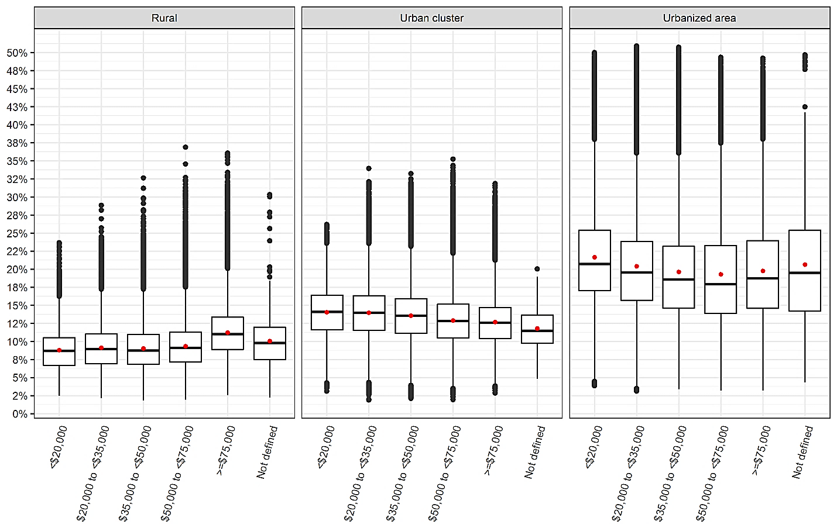

*\*Red dot represents the mean value while the midline represents the median value*

Figure 3: Attributable fraction by state

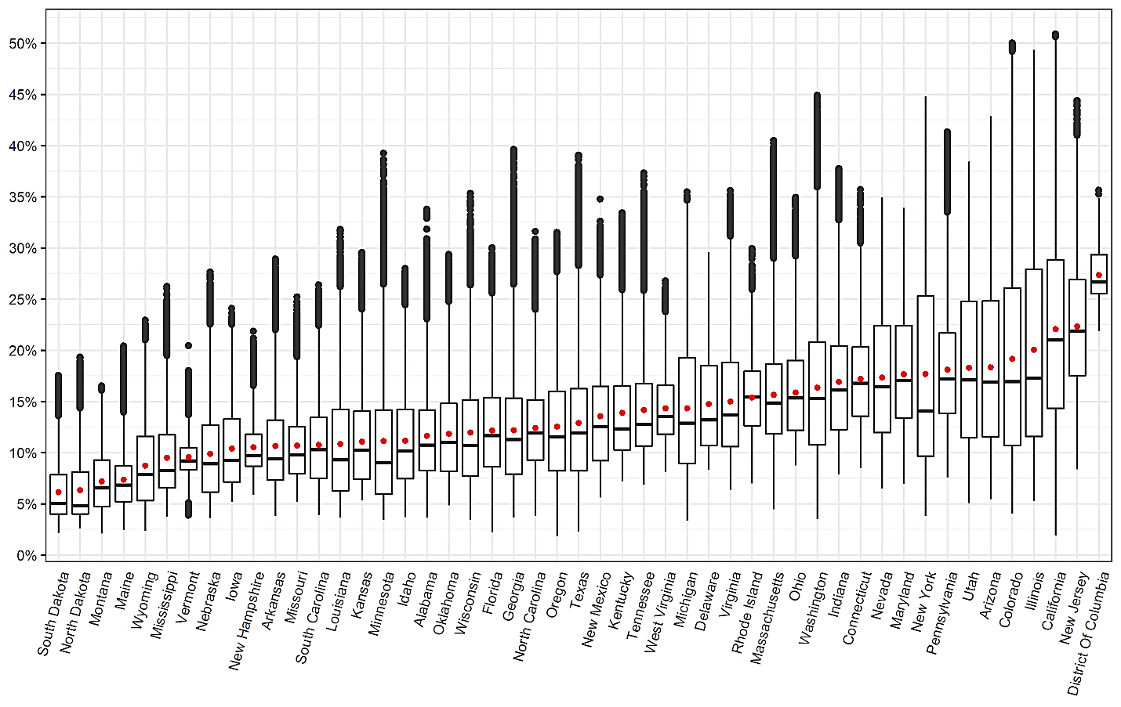

Figure 4 and Figure 5 present the distribution of attributable fraction by living location and median household income group for each state. The majority of states broadly follow a distribution similar to the national level as shown in , with a few exceptions (see Arizona, Connecticut, Massachusetts, Montana, New Hampshire, Rhode Island & Wyoming).

Figure 4: Attributable fraction by state and living location

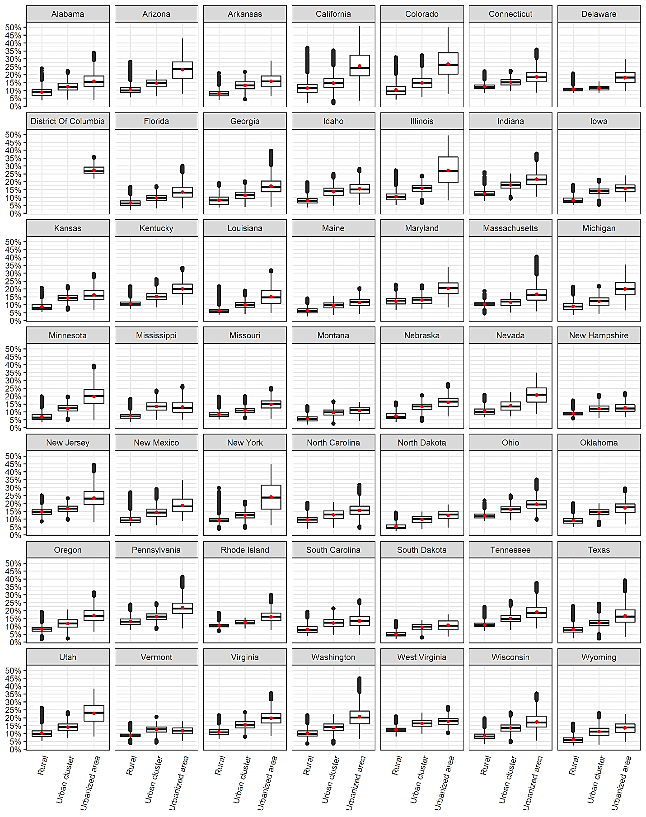

Figure 5: Attributable fraction by state and median household income group

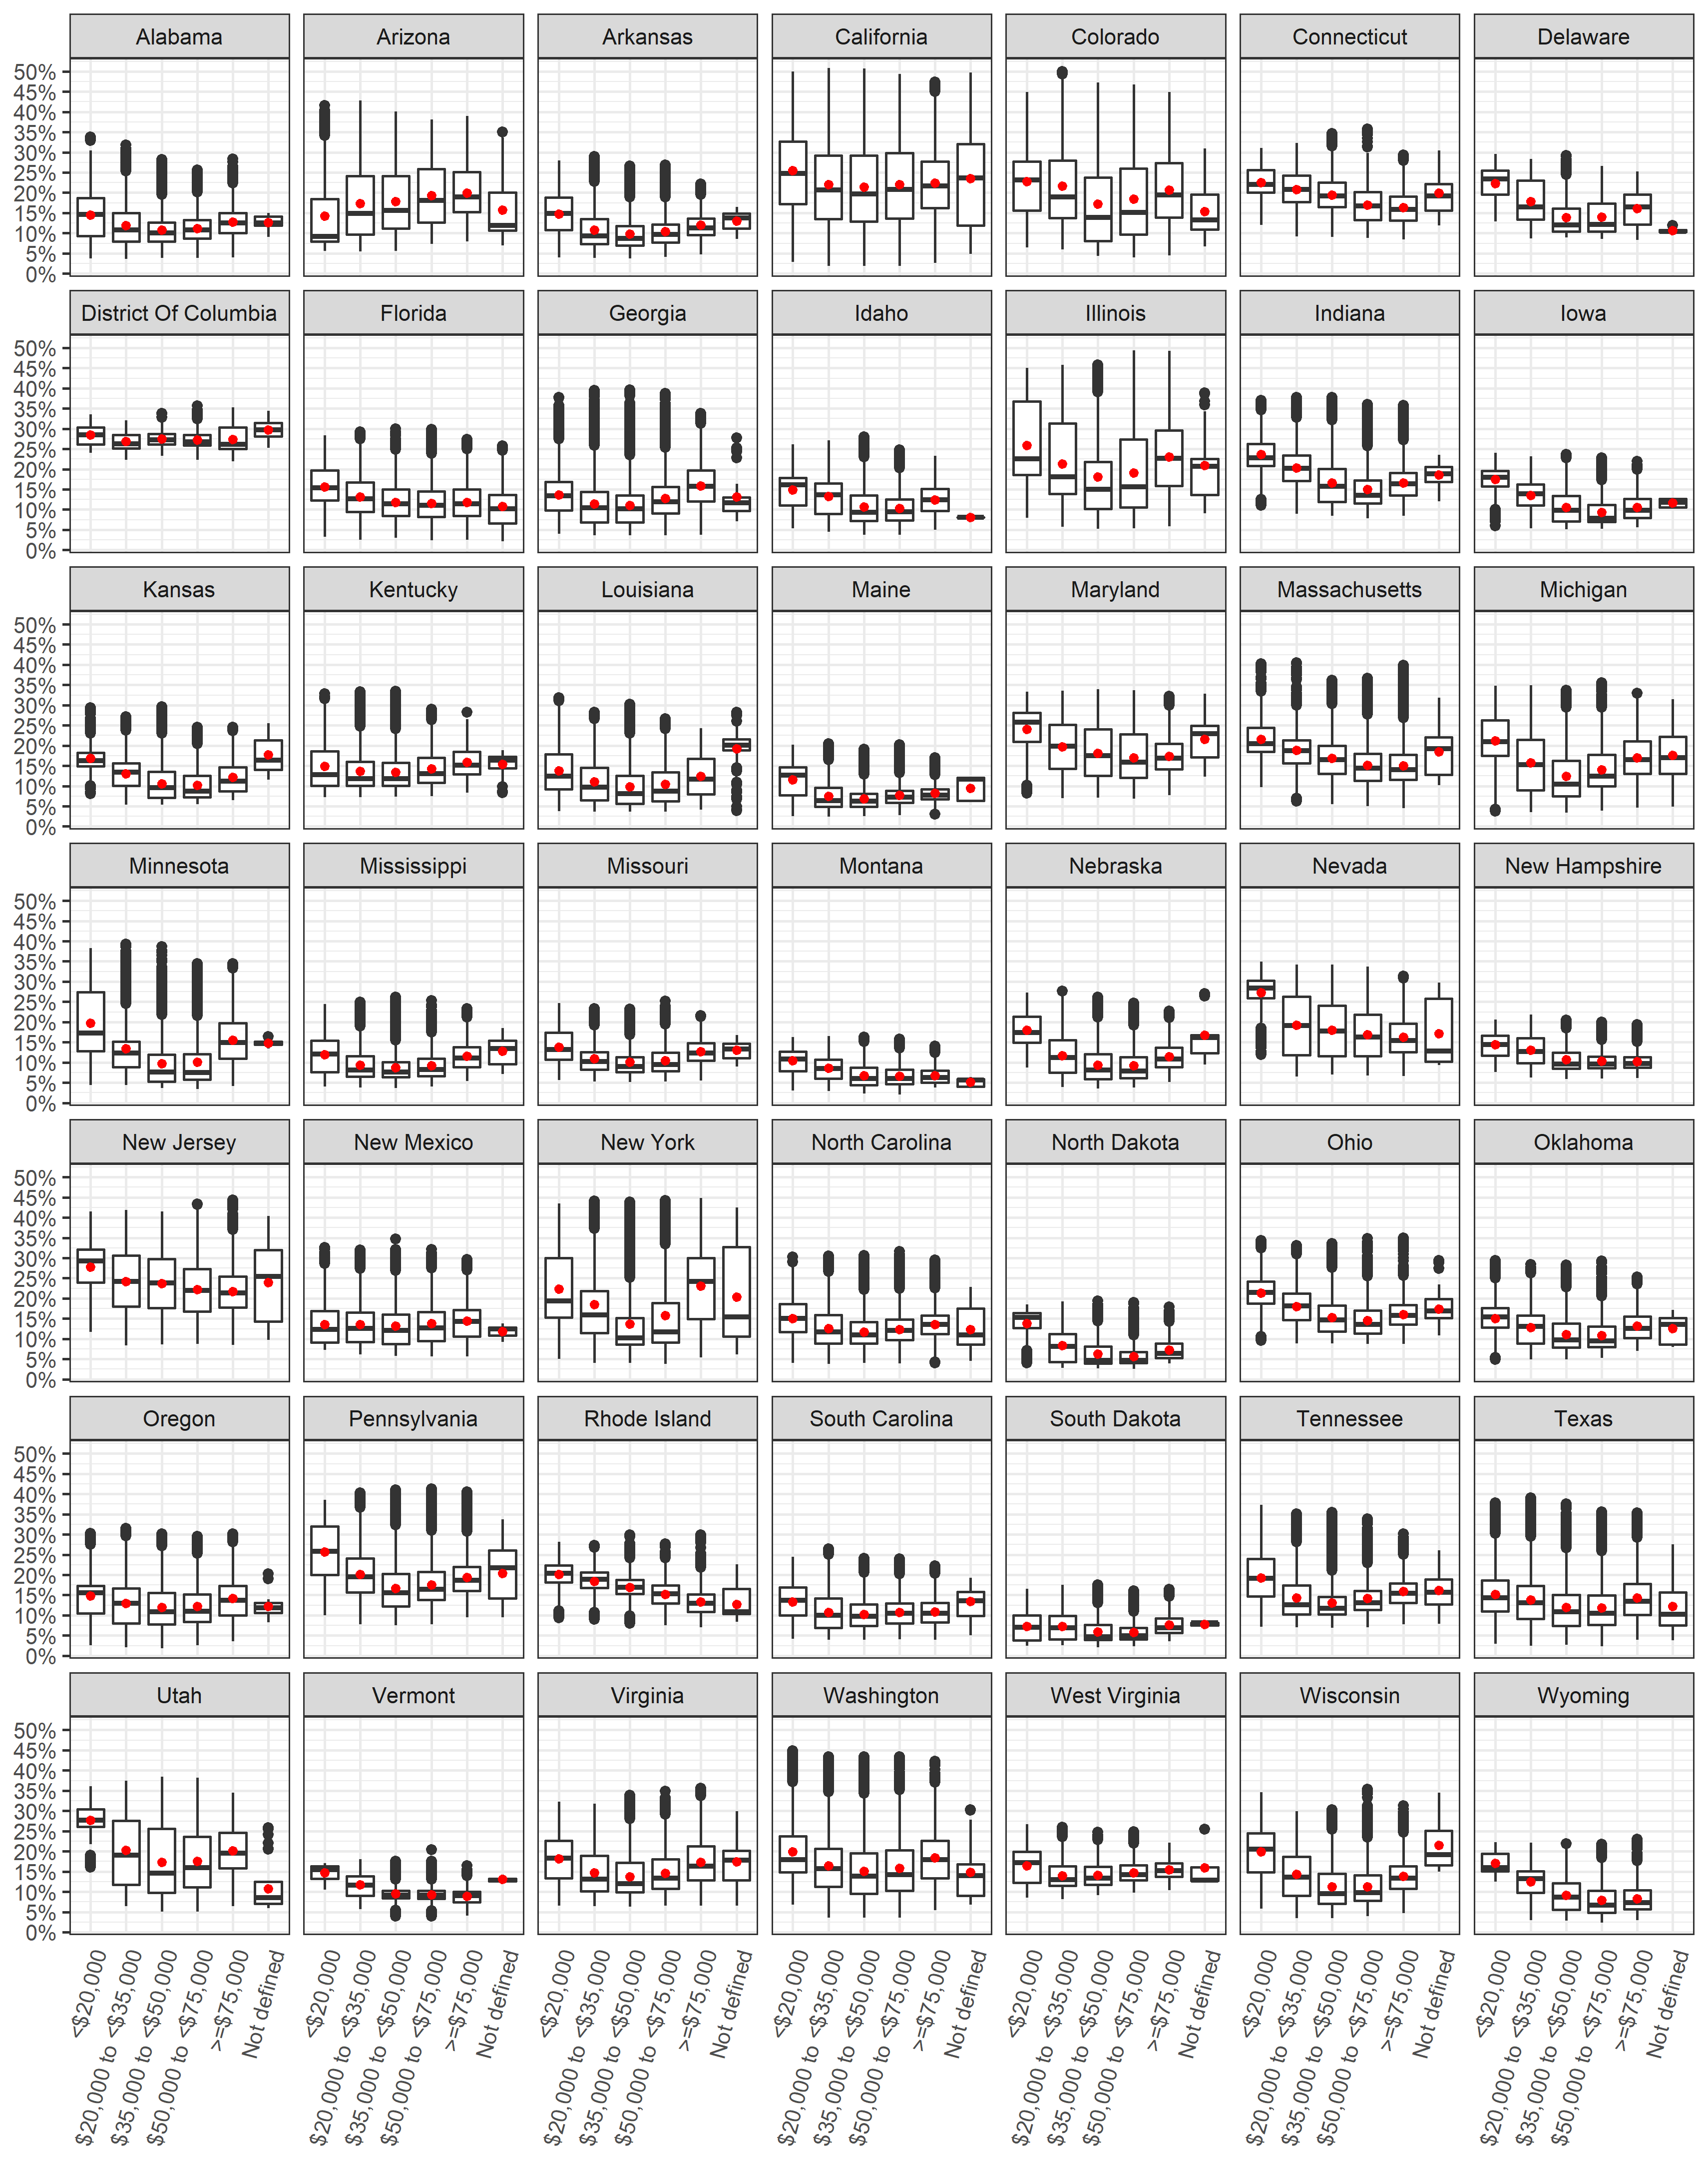

*Comparison with the original paper*

*Comparing total asthma incident cases*

Using state-specific asthma incidence rates, the overall number of cases was reduced by an average of 40,041 (5%) cases compared to estimates presented in the original paper which used a flat national asthma incidence rate (Table 4). By living location, the largest reduction was among urban clusters with a decrease of 4,204 (5.6%) cases followed by urbanized areas which reduced by 29,926 (5.2%) cases. By income group, the largest decrease in the number of cases was among the highest income groups by 13,123 (6.8%) cases, while the least decrease was among the lowest income group by 168 (0.6%) cases. The state of California had the largest decrease in numbers of total childhood asthma incident cases by 24,442 cases while the state of Texas had the largest increase in numbers of total childhood asthma incident cases by 25,019 cases (Table S4). The state of Montana had the largest percent reduction in total childhood asthma incident cases by 64.1% while the state of Texas had the largest percent increase by 33.8%.

*Comparing attributable asthma incident cases*

The total attributable cases reduced by 9,103 (6.4%) cases when compared to the original paper which used a flat national asthma incidence rate (Table 4). By living location, urbanized areas had the largest reduction by 8,040 (6.8%) cases, while rural areas had the least reduction by 514 (3.6%) cases attributable to NO2 exposure. By income group, the highest income group had the largest decrease in attributable cases by 2,994 (8.5%) while the lowest income group had the least decrease by 58 (1%) cases. The state of California had the largest decrease in attributable cases by 6,190 cases while the state of Texas had the largest increase by 3,615 cases (Table S4).

*Comparing attributable asthma incident fractions*

The overall attributable fraction reduced 1.4% with urbanized areas having the largest reduction by 1.7% in terms of living location. In terms of income group, the largest reduction was 1.8% for both $50,000 to <$75,000 and ≥$75,000 groups (Table 4). The attributable fraction across states did not differ when using state-specific asthma incidence rates.

**Discussion**

* Using state-specific asthma incidence rates did not change the results much (within the range of the sensitivity analysis from the main paper)
* The state-specific total number of asthma cases and attributable cases changed when applying state-specific incidence rates
* The state-specific attributable fractions did not change. The reason is that the incident rate is applied uniformly across the state (spatially), thus the total asthma cases and total attributable cases will change with equal proportion when applying the new asthma incidence rate but not the attributable fraction. The attributable fraction is a function of CRF and exposure estimate regardless of the IR. Had we applied an incidence rate based on other factors like age, gender, race, income group, then the attributable fraction across the state would differ since the change won’t in incidence rate won’t be uniform within the state.
* The percentage of all asthma cases has a U shaped distribution when examining income groups. The lowest income group had the highest % then drops and rises again with the highest income group.
* Explore why the U shaped distribution is shown among attributable fraction for income groups.

**Conclusions**

**Funding**

This research was made possible by funding from the Texas A&M Transportation Institute's (TTI) Center for Advancing Research in Transportation Emissions, Energy, and Health (CARTEEH), a U.S. Department of Transportation's University Transportation Center with the grant number ([69A3551747128](https://www.sciencedirect.com/science/article/pii/S0160412018325388#gts0010)).

**Disclaimer**

The contents of this report reflect the views of the authors, who are responsible for the facts and the accuracy of the information presented herein. This document is disseminated in the interest of information exchange. The report is funded, partially or entirely, by a grant from the U.S. Department of Transportation's University Transportation Centers Program. However, the U.S. Government assumes no liability for the contents or use thereof.

**References**

ACHAKULWISUT, P., BRAUER, M., HYSTAD, P. & ANENBERG, S. C. 2019. Global, national, and urban burdens of paediatric asthma incidence attributable to ambient NO2 pollution: estimates from global datasets. *The Lancet Planetary Health,* 3**,** e166-e178.

ALOTAIBI, R., BECHLE, M., MARSHALL, J. D., RAMANI, T., ZIETSMAN, J., NIEUWENHUIJSEN, M. J. & KHREIS, H. 2019. Traffic related air pollution and the burden of childhood asthma in the contiguous United States in 2000 and 2010. *Environment International*.

AMERICAN LUNG ASSOCIATION, E. A. S. U. 2019. *Lung Health & Diseases: Asthma and Children Fact Sheet* [Online]. Available: <https://www.lung.org/lung-health-and-diseases/lung-disease-lookup/asthma/learn-about-asthma/asthma-children-facts-sheet.html> [Accessed].

BECHLE, M. J., MILLET, D. B. & MARSHALL, J. D. 2015. National Spatiotemporal Exposure Surface for NO2: Monthly Scaling of a Satellite-Derived Land-Use Regression, 2000–2010. *Environmental science & technology,* 49**,** 12297-12305.

BEELEN, R., HOEK, G., PEBESMA, E., VIENNEAU, D., DE HOOGH, K. & BRIGGS, D. J. 2009. Mapping of background air pollution at a fine spatial scale across the European Union. *Science of the Total Environment,* 407**,** 1852-1867.

BHALLA, K., SHOTTEN, M., COHEN, A., BRAUER, M., SHAHRAZ, S., BURNETT, R., LEACH-KEMON, K., FREEDMAN, G. & MURRAY, C. 2014. *Transport for health: the global burden of disease from motorized road transport*.

CDC 2009. Centers for Disease Control and Prevention. Behavioral Risk Factor Surveillance System Survey Data. Atlanta, Georgia: U.S. Department of Health and Human Services, Centers for Disease Control and Prevention, 2019.

CDC 2011. Centers for Disease Control and Prevention. 2006-2008 ACBS Summary Data Qulaity Report. 2011.

CLARK, L. P., MILLET, D. B. & MARSHALL, J. D. 2017. Changes in transportation-related air pollution exposures by race-ethnicity and socioeconomic status: Outdoor nitrogen dioxide in the United States in 2000 and 2010. *Environmental Health Perspectives,* 125**,** 1--10.

COHEN, A. J., BRAUER, M., BURNETT, R., ANDERSON, H. R., FROSTAD, J., ESTEP, K., BALAKRISHNAN, K., BRUNEKREEF, B., DANDONA, L. & DANDONA, R. 2017. Estimates and 25-year trends of the global burden of disease attributable to ambient air pollution: an analysis of data from the Global Burden of Diseases Study 2015. *The Lancet,* 389**,** 1907-1918.

COHEN, A. J., ROSS ANDERSON, H., OSTRO, B., PANDEY, K. D., KRZYZANOWSKI, M., KÜNZLI, N., GUTSCHMIDT, K., POPE, A., ROMIEU, I. & SAMET, J. M. 2005. The global burden of disease due to outdoor air pollution. *Journal of Toxicology and Environmental Health, Part A,* 68**,** 1301-1307.

GARBE, P., BALLUZ, L. S. & CHIEF, B. 2011. Behavioral Risk Factor Surveillance System Asthma Call-Back Survey History And Analysis Guidance.

GASANA, J., DILLIKAR, D., MENDY, A., FORNO, E. & RAMOS VIEIRA, E. 2012. Motor vehicle air pollution and asthma in children: a meta-analysis. *Environmental Research,* 117**,** 36-45.

HSU, J., QIN, X., BEAVERS, S. F. & MIRABELLI, M. C. 2016. Asthma-related school absenteeism, morbidity, and modifiable factors. *American journal of preventive medicine,* 51**,** 23-32.

HYSTAD, P., SETTON, E., CERVANTES, A., POPLAWSKI, K., DESCHENES, S., BRAUER, M., VAN DONKELAAR, A., LAMSAL, L., MARTIN, R. & JERRETT, M. 2011. Creating national air pollution models for population exposure assessment in Canada. *Environmental health perspectives,* 119**,** 1123.

KHREIS, H., DE HOOGH, K. & NIEUWENHUIJSEN, M. J. 2018a. Full-chain health impact assessment of traffic-related air pollution and childhood asthma. *Environment international,* 114**,** 365-375.

KHREIS, H., KELLY, C., TATE, J., PARSLOW, R., LUCAS, K. & NIEUWENHUIJSEN, M. 2017. Exposure to Traffic-related Air Pollution and Risk of Development of Childhood Asthma: A Systematic Review and Meta-analysis. *Environment International,* 100**,** 1-31.

KHREIS, H., RAMANI, T., DE HOOGH, K., MUELLER, N., ROJAS-RUEDA, D., ZIETSMAN, J. & NIEUWENHUIJSEN, M. J. 2018b. Traffic-Related Air Pollution and the Local Burden of Childhood Asthma in Bradford, UK. *International Journal of Transportation Science and Technology*.

KHREIS, H. C., MARTA; MUELLER, NATALIE; KEES DE HOOGH; HOEK, GERARD; NIEUWENHUIJSEN, MARK J; ROJAS-RUEDA, DAVID; In prep. Outdoor Air Pollution and the Burden of Childhood Asthma across Europe. *European Respiratory Journal*.

KORN, E. L. & GRAUBARD, B. I. 2011. *Analysis of health surveys*, John Wiley & Sons.

LEE, J.-Y., LEEM, J.-H., KIM, H.-C., LAMICHHANE, D. K., HWANG, S.-S., KIM, J.-H., PARK, M.-S., JUNG, D.-Y., KO, J.-K. & KWON, H.-J. 2018. Effects of traffic-related air pollution on susceptibility to infantile bronchiolitis and childhood asthma: a cohort study in Korea. *Journal of Asthma,* 55**,** 223-230.

LELIEVELD, J., EVANS, J. S., FNAIS, M., GIANNADAKI, D. & POZZER, A. 2015. The contribution of outdoor air pollution sources to premature mortality on a global scale. *Nature,* 525**,** 367.

MANSON, S., SCHROEDER, J., VAN RIPER, D. & RUGGLES, S. 2018. IPUMS National Historical Geographic Information System: Version 13.0 [Database]. Minneapolis: University of Minnesota.

MAUSNER, J. & KRAMER, S. 1985. Epidemiology: An Introductory Text. Phila-delphia. *PA: Saunders*.

MUELLER, N., ROJAS-RUEDA, D., BASAGAÑA, X., CIRACH, M., COLE-HUNTER, T., DADVAND, P., DONAIRE-GONZALEZ, D., FORASTER, M., GASCON, M. & MARTINEZ, D. 2017. Urban and transport planning related exposures and mortality: a health impact assessment for cities. *Environmental Health Perspectives,* 125**,** 89-96.

NATIONAL SURVEY OF CHILDREN'S HEALTH, N. 2012. Data query from the Child and Adolescent Health Measurement Initiative. Data Resource Center for Child and Adolescent Health website.

NOVOTNY, E. V., BECHLE, M. J., MILLET, D. B. & MARSHALL, J. D. 2011. National satellite-based land-use regression: NO2 in the United States. *Environmental science & technology,* 45**,** 4407-4414.

NURMAGAMBETOV, T., KUWAHARA, R. & GARBE, P. 2018. The economic burden of asthma in the United States, 2008–2013. *Annals of the American Thoracic Society,* 15**,** 348-356.

OSTRO, B. & ORGANIZATION, W. H. 2004. Outdoor air pollution: assessing the environmental burden of disease at national and local levels.

PENNINGTON, A. F., STRICKLAND, M. J., KLEIN, M., ZHAI, X., BATES, J. T., DREWS-BOTSCH, C., HANSEN, C., RUSSELL, A. G., TOLBERT, P. E. & DARROW, L. A. 2018. Exposure to mobile source air pollution in early-life and childhood asthma incidence: the Kaiser Air Pollution and Pediatric Asthma Study. *Epidemiology,* 29**,** 22-30.

PEREZ, L., DECLERCQ, C., IÑIGUEZ, C., AGUILERA, I., BADALONI, C., BALLESTER, F., BOULAND, C., CHANEL, O., CIRARDA, F. B. & FORASTIERE, F. 2013. Chronic burden of near-roadway traffic pollution in 10 European cities (APHEKOM network). *European Respiratory Journal***,** erj00311-2012.

PEREZ, L., KÜNZLI, N., AVOL, E., HRICKO, A. M., LURMANN, F., NICHOLAS, E., GILLILAND, F., PETERS, J. & MCCONNELL, R. 2009. Global goods movement and the local burden of childhood asthma in southern California. *American Journal of Public Health,* 99**,** S622-S628.

R CORE TEAM 2018. R: A Language and Environment for Statistical Computing. R Foundation for Statistical Computing.

RANCIÈRE, F., BOUGAS, N., VIOLA, M. & MOMAS, I. 2016. Early exposure to traffic-related air pollution, respiratory symptoms at 4 years of age, and potential effect modification by parental allergy, stressful family events, and sex: a prospective follow-up study of the PARIS birth cohort. *Environmental health perspectives,* 125**,** 737-745.

RICE, M. B., RIFAS-SHIMAN, S. L., LITONJUA, A. A., GILLMAN, M. W., LIEBMAN, N., KLOOG, I., LUTTMANN-GIBSON, H., COULL, B. A., SCHWARTZ, J. & KOUTRAKIS, P. 2018. Lifetime air pollution exposure and asthma in a pediatric birth cohort. *Journal of Allergy and Clinical Immunology,* 141**,** 1932-1934. e7.

TAINIO, M. 2015. Burden of disease caused by local transport in Warsaw, Poland. *Journal of transport & health,* 2**,** 423-433.

US CENSUS BUREAU 2010. American factfinder. US Census Bureau Washington, DC.

US CENSUS BUREAU. 2016. *Defining rural at the U.S. census bureau* [Online]. Available: <https://www.census.gov/library/publications/2016/acs/acsgeo-1.html> [Accessed].

VIENNEAU, D., DE HOOGH, K., BECHLE, M. J., BEELEN, R., VAN DONKELAAR, A., MARTIN, R. V., MILLET, D. B., HOEK, G. & MARSHALL, J. D. 2013. Western European land use regression incorporating satellite-and ground-based measurements of NO2 and PM10. *Environmental science & technology,* 47**,** 13555-13564.

WHO 2005. Air Quality Guidlines Global Update 2005.

WINER, R. A., QIN, X., HARRINGTON, T., MOORMAN, J. & ZAHRAN, H. 2012. Asthma incidence among children and adults: findings from the Behavioral Risk Factor Surveillance system asthma call-back survey—United States, 2006–2008. *Journal of Asthma,* 49**,** 16-22.

ZAHRAN, H. S., BAILEY, C. M., DAMON, S. A., GARBE, P. L. & BREYSSE, P. N. 2018. Vital signs: asthma in children—United States, 2001–2016. *Morbidity and Mortality Weekly Report,* 67**,** 149.

**Supplementary Material**

Table S1: NO2 concentration (ug/m3) by state 24

Table S2: Available childhood asthma incidence rates by state and year 26

Table S3: Childhood asthma survey summary by state (Total of 2006-2010) 28

Table S4: State-specific results and comparison 30

Table S5: Comparing results by state 32

Figure S1: NO2 concentration (ug/m3) by living location 34

Figure S2: NO2 concentration (ug/m3) by median household income group 35

Figure S3: NO2 concentration (ug/m3) by living location stratified into median household income group 35

Figure S4: NO2 concentration (ug/m3) by median household income group stratified into living location 36

Figure S5: NO2 concentration (ug/m3) by state 36

Figure S6: NO2 concentration (ug/m3) by state and median household income group 37

Figure S7: NO2 concentration (ug/m3) by state and living location 38

Figure S8: Attributable Fraction by living location 39

Figure S9: Attributable Fraction by median household income group 39

Figure S10: Attributable Fraction by median household income group stratified into living location 40

Table S1: NO2 concentration (ug/m3) by state

|  |  |  |  |  |  |  |
| --- | --- | --- | --- | --- | --- | --- |
| **State** | **Mean** | **Min** | **25%** | **Median** | **75%** | **Max** |
| Alabama | 10.3 | 3.0 | 7.1 | 9.3 | 12.5 | 33.8 |
| Arizona | 17.0 | 4.6 | 10.1 | 15.1 | 23.4 | 45.9 |
| Arkansas | 9.3 | 3.2 | 6.2 | 8.1 | 11.6 | 28.0 |
| California | 21.1 | 1.6 | 12.7 | 19.3 | 27.9 | 58.3 |
| Colorado | 18.1 | 3.4 | 9.3 | 15.2 | 24.8 | 56.9 |
| Connecticut | 15.6 | 7.3 | 11.9 | 15.0 | 18.6 | 36.2 |
| Delaware | 13.2 | 7.1 | 9.3 | 11.6 | 16.7 | 28.7 |
| District of Columbia | 26.3 | 20.2 | 24.2 | 25.4 | 28.5 | 36.1 |
| Florida | 10.7 | 1.8 | 7.4 | 10.2 | 13.7 | 29.2 |
| Georgia | 10.8 | 3.0 | 6.8 | 9.8 | 13.6 | 41.4 |
| Idaho | 9.8 | 3.1 | 6.4 | 8.8 | 12.6 | 26.9 |
| Illinois | 19.0 | 4.4 | 10.1 | 15.5 | 26.9 | 55.7 |
| Indiana | 15.4 | 6.7 | 10.7 | 14.4 | 18.7 | 38.9 |
| Iowa | 9.1 | 4.3 | 6.1 | 8.0 | 11.7 | 22.6 |
| Kansas | 9.7 | 4.5 | 6.3 | 8.8 | 12.4 | 28.7 |
| Kentucky | 12.4 | 6.1 | 8.9 | 10.8 | 14.8 | 33.3 |
| Louisiana | 9.6 | 3.0 | 5.3 | 8.0 | 12.6 | 31.4 |
| Maine | 6.3 | 2.0 | 4.4 | 5.8 | 7.5 | 18.7 |
| Maryland | 16.1 | 5.9 | 11.8 | 15.3 | 20.8 | 34.0 |
| Massachusetts | 14.1 | 3.7 | 10.3 | 13.2 | 17.0 | 42.5 |
| Michigan | 12.9 | 2.8 | 7.7 | 11.3 | 17.5 | 35.9 |
| Minnesota | 9.9 | 2.9 | 5.0 | 7.8 | 12.5 | 40.8 |
| Mississippi | 8.3 | 3.1 | 5.6 | 7.0 | 10.2 | 24.9 |
| Missouri | 9.3 | 4.4 | 6.8 | 8.4 | 11.0 | 23.8 |
| Montana | 6.2 | 1.7 | 4.0 | 5.5 | 8.0 | 14.8 |
| Nebraska | 8.6 | 3.0 | 5.2 | 7.7 | 11.1 | 26.5 |
| Nevada | 15.9 | 5.5 | 10.5 | 14.7 | 20.8 | 35.2 |
| New Hampshire | 9.1 | 5.0 | 7.4 | 8.4 | 10.3 | 20.2 |
| New Jersey | 21.0 | 7.1 | 15.8 | 20.2 | 25.7 | 48.1 |
| New Mexico | 12.1 | 4.7 | 7.9 | 11.0 | 14.8 | 35.0 |
| New York | 16.6 | 3.2 | 8.3 | 12.4 | 23.9 | 48.7 |
| North Carolina | 11.0 | 3.2 | 8.0 | 10.4 | 13.5 | 31.1 |
| North Dakota | 5.4 | 2.1 | 3.3 | 4.0 | 6.9 | 17.6 |
| Ohio | 14.3 | 7.5 | 10.7 | 13.6 | 17.3 | 35.2 |
| Oklahoma | 10.4 | 4.1 | 7.0 | 9.5 | 13.1 | 28.5 |
| Oregon | 11.1 | 1.5 | 7.0 | 10.1 | 14.3 | 31.0 |
| Pennsylvania | 16.6 | 6.4 | 12.2 | 15.5 | 20.1 | 43.7 |
| Rhode Island | 13.8 | 5.9 | 11.1 | 13.7 | 16.2 | 29.2 |
| South Carolina | 9.4 | 3.3 | 6.4 | 8.9 | 11.9 | 25.1 |
| South Dakota | 5.2 | 1.8 | 3.3 | 4.2 | 6.7 | 15.8 |
| Tennessee | 12.7 | 5.9 | 9.2 | 11.2 | 15.0 | 38.3 |
| Texas | 11.5 | 1.9 | 7.0 | 10.4 | 14.5 | 40.6 |
| Utah | 17.0 | 4.3 | 10.0 | 15.4 | 23.4 | 39.8 |
| Vermont | 8.3 | 3.3 | 7.1 | 7.9 | 9.1 | 18.7 |
| Virginia | 13.5 | 5.3 | 9.2 | 12.0 | 17.1 | 36.1 |
| Washington | 14.9 | 2.9 | 9.3 | 13.6 | 19.1 | 48.9 |
| West Virginia | 12.7 | 6.9 | 10.3 | 11.9 | 14.9 | 25.5 |
| Wisconsin | 10.6 | 2.8 | 6.6 | 9.3 | 13.5 | 35.7 |
| Wyoming | 7.6 | 2.0 | 4.5 | 6.7 | 10.1 | 21.4 |

Table S2: Available childhood asthma incidence rates by state and year

|  |  |  |  |  |  |  |
| --- | --- | --- | --- | --- | --- | --- |
| **State** | **2006\*** | **2007\*** | **2008\*** | **2009\*** | **2010\*** | **Aggregate IR\*** |
| Alabama |  |  |  |  |  |  |
| Alaska |  |  |  |  |  |  |
| Arizona | 23.7 | 6.8 |  |  |  | 15.2 |
| Arkansas |  |  |  |  |  |  |
| California | 12.1 | 6.5 |  |  |  | 9.3 |
| Colorado |  |  |  |  |  |  |
| Connecticut |  | 9.9 | 14.1 | 10.8 | 13.5 | 12.0 |
| Delaware |  |  |  |  |  |  |
| District of Columbia | 5.3 | 28.8 |  |  |  | 17.7 |
| Florida |  |  |  |  |  |  |
| Georgia | 6.4 | 5.8 | 9.1 | 16.6 | 6.9 | 9.1 |
| Hawaii |  |  |  |  |  |  |
| Idaho |  |  |  |  |  |  |
| Illinois |  | 4.2 |  | 9.2 |  | 6.7 |
| Indiana | 25.4 | 9.3 | 13.4 | 9.9 | 17.6 | 15.2 |
| Iowa | 5.0 | 4.0 | 9.9 |  |  | 6.3 |
| Kansas | 7.8 | 9.9 | 9.9 | 8.3 | 9.0 | 9.0 |
| Kentucky |  |  |  |  |  |  |
| Louisiana |  |  |  | 5.8 |  | 5.8 |
| Maine | 13.0 | 8.7 | 5.8 |  |  | 9.2 |
| Maryland | 16.2 | 8.6 | 11.0 | 17.3 | 2.3 | 11.2 |
| Massachusetts |  |  |  |  |  |  |
| Michigan | 5.3 | 7.7 | 5.2 | 13.4 | 29.3 | 12.0 |
| Minnesota |  |  |  |  |  |  |
| Mississippi |  | 10.8 |  |  | 17.2 | 14.0 |
| Missouri | 21.2 | 10.3 | 7.2 |  |  | 12.9 |
| Montana | 2.8 | 2.0 |  | 3.7 | 8.5 | 4.3 |
| Nebraska | 11.9 | 8.3 | 8.9 | 3.3 | 12.9 | 9.1 |
| Nevada |  |  |  |  |  |  |
| New Hampshire | 11.5 | 13.8 | 10.4 |  |  | 12.0 |
| New Jersey |  |  | 6.3 | 12.5 | 10.5 | 9.8 |
| New Mexico |  | 3.2 | 9.5 |  | 7.2 | 6.7 |
| New York | 12.9 | 6.1 | 28.4 | 11.2 |  | 14.7 |
| North Carolina |  |  |  |  |  |  |
| North Dakota |  |  |  |  |  |  |
| Ohio |  | 13.1 | 17.0 |  |  | 15.1 |
| Oklahoma |  | 9.2 | 10.1 |  | 12.9 | 10.8 |
| Oregon |  | 11.1 |  |  |  | 11.1 |
| Pennsylvania |  | 21.8 |  |  | 4.3 | 13.2 |
| Rhode Island |  |  | 15.3 | 13.2 |  | 14.3 |
| South Carolina |  |  |  |  |  |  |
| South Dakota |  |  |  |  |  |  |
| Tennessee |  |  |  |  |  |  |
| Texas | 14.4 |  | 18.2 | 12.5 | 21.0 | 16.6 |
| Utah |  | 15.4 | 11.9 | 5.6 | 9.3 | 10.4 |
| Vermont | 13.5 | 4.4 | 8.5 | 21.2 | 10.4 | 11.5 |
| Virginia |  |  |  |  |  |  |
| Washington |  |  |  | 7.9 | 5.6 | 6.8 |
| West Virginia |  | 11.8 |  |  |  | 11.8 |
| Wisconsin | 12.3 |  |  |  |  | 12.3 |
| Wyoming |  |  |  |  |  |  |

*\*Incidence rate per 1,000 at-risk children*

Table S3: Childhood asthma survey summary by state (Total of 2006-2010)

|  |  |  |  |  |
| --- | --- | --- | --- | --- |
| **State** | **Total ACBS sample** | **Total BRFSS sample** | **Total ever asthma** | **Total incident cases** |
| Arizona | 103 | 5,535 | 699 | 10 |
| California | 172 | 11,801 | 1,543 | 13 |
| Connecticut | 549 | 7,112 | 1,132 | 47 |
| D.C. | 69 | 4,101 | 685 | 6 |
| Georgia | 545 | 9,433 | 1,455 | 26 |
| Illinois | 122 | 6,187 | 778 | 6 |
| Indiana | 500 | 9,824 | 1,361 | 41 |
| Iowa | 245 | 8,084 | 724 | 19 |
| Kansas | 827 | 14,699 | 1,839 | 50 |
| Louisiana | 88 | 8,829 | 1,214 | 4 |
| Maine | 376 | 4,523 | 644 | 23 |
| Maryland | 624 | 13,093 | 1,897 | 44 |
| Michigan | 680 | 10,762 | 1,524 | 43 |
| Mississippi | 208 | 10,816 | 1,527 | 14 |
| Missouri | 262 | 5,646 | 814 | 20 |
| Montana | 286 | 8,609 | 909 | 17 |
| Nebraska | 717 | 17,883 | 1,644 | 53 |
| New Hampshire | 232 | 5,285 | 664 | 19 |
| New Jersey | 458 | 15,410 | 2,230 | 32 |
| New Mexico | 287 | 5,554 | 765 | 17 |
| New York | 404 | 7,083 | 1,079 | 28 |
| Ohio | 351 | 7,989 | 1,138 | 32 |
| Oklahoma | 299 | 8,611 | 1,291 | 21 |
| Oregon | 165 | 4,793 | 579 | 13 |
| Pennsylvania | 209 | 14,760 | 2,090 | 12 |
| Rhode Island | 169 | 7,127 | 1,209 | 11 |
| Texas | 780 | 16,749 | 2,293 | 55 |
| Utah | 573 | 14,417 | 1,617 | 45 |
| Vermont | 597 | 8,784 | 1,220 | 40 |
| Washington | 594 | 9,706 | 1,165 | 33 |
| West Virginia | 85 | 5,089 | 663 | 5 |
| Wisconsin | 140 | 5,170 | 611 | 10 |

\**Incidence rate* per 1,000 at-risk children

\**Prevalence rate per 100 children*

Table S4: State-specific results and comparison

|  |  |  |  |  |  |  |  |  |  |
| --- | --- | --- | --- | --- | --- | --- | --- | --- | --- |
|  | **Main results** | | | | **Comparison** | | **Difference** | | |
| **State** | **Total children** | **Incident cases** | **AC** | **AF** | **Origin cases** | **Origin AC** | **Incident cases** | **AC** | **%** |
| **Alabama** | 1,132,459 | 11,700 | 1,380 | 11.8% | 12,216 | 1,439 | -494 | -58 (-4.0%) | -4.0% |
| **Arizona** | 1,629,014 | 21,500 | 4,620 | 21.5% | 17,573 | 3,772 | 3,965 | 851 (22.6%) | 22.6% |
| **Arkansas** | 711,475 | 7,500 | 860 | 11.6% | 7,675 | 887 | -199 | -23 (-2.6%) | -2.6% |
| **California** | 9,295,040 | 75,800 | 19,200 | 25.3% | 100,270 | 25,395 | -24,442 | -6,190 (-24.4%) | -24.4% |
| **Colorado** | 1,225,609 | 12,900 | 3,010 | 23.4% | 13,221 | 3,089 | -342 | -80 (-2.6%) | -2.6% |
| **Connecticut** | 817,015 | 8,300 | 1,500 | 18.2% | 8,814 | 1,601 | -549 | -100 (-6.2%) | -6.2% |
| **Delaware** | 205,765 | 2,000 | 330 | 16.0% | 2,220 | 355 | -184 | -29 (-8.3%) | -8.3% |
| **D.C.** | 100,815 | 1,400 | 390 | 26.9% | 1,088 | 293 | 346 | 93 (31.8%) | 31.8% |
| **Florida** | 4,002,091 | 42,100 | 5,360 | 12.7% | 43,173 | 5,502 | -1,118 | -142 (-2.6%) | -2.6% |
| **Georgia** | 2,491,552 | 19,200 | 2,770 | 14.5% | 26,878 | 3,887 | -7,713 | -1,115 (-28.7%) | -28.7% |
| **Idaho** | 429,072 | 4,700 | 590 | 12.6% | 4,629 | 581 | 96 | 12 (2.1%) | 2.1% |
| **Illinois** | 3,129,179 | 18,300 | 4,510 | 24.7% | 33,756 | 8,333 | -15,492 | -3,824 (-45.9%) | -45.9% |
| **Indiana** | 1,608,298 | 21,300 | 3,850 | 18.1% | 17,350 | 3,143 | 3,913 | 709 (22.6%) | 22.6% |
| **Iowa** | 727,993 | 4,200 | 520 | 12.4% | 7,853 | 971 | -3,660 | -453 (-46.6%) | -46.6% |
| **Kansas** | 726,939 | 5,800 | 790 | 13.6% | 7,842 | 1,067 | -2,061 | -281 (-26.3%) | -26.3% |
| **Kentucky** | 1,023,371 | 10,700 | 1,590 | 14.9% | 11,040 | 1,649 | -389 | -58 (-3.5%) | -3.5% |
| **Louisiana** | 1,118,015 | 5,600 | 650 | 11.6% | 12,061 | 1,401 | -6,445 | -749 (-53.4%) | -53.4% |
| **Maine** | 274,533 | 2,200 | 170 | 7.9% | 2,962 | 234 | -766 | -60 (-25.9%) | -25.9% |
| **Maryland** | 1,352,964 | 12,800 | 2,450 | 19.1% | 14,595 | 2,787 | -1,746 | -333 (-12.0%) | -12.0% |
| **Massachusetts** | 1,418,923 | 14,900 | 2,470 | 16.6% | 15,307 | 2,539 | -396 | -66 (-2.6%) | -2.6% |
| **Michigan** | 2,344,068 | 24,400 | 4,060 | 16.7% | 25,287 | 4,211 | -931 | -155 (-3.7%) | -3.7% |
| **Minnesota** | 1,284,063 | 14,100 | 2,120 | 15.1% | 13,852 | 2,093 | 210 | 32 (1.5%) | 1.5% |
| **Mississippi** | 755,555 | 9,100 | 930 | 10.2% | 8,151 | 832 | 951 | 97 (11.7%) | 11.7% |
| **Missouri** | 1,425,436 | 15,800 | 1,900 | 12.0% | 15,377 | 1,845 | 445 | 53 (2.9%) | 2.9% |
| **Montana** | 223,563 | 900 | 70 | 8.0% | 2,412 | 192 | -1,546 | -123 (-64.1%) | -64.1% |
| **Nebraska** | 459,221 | 3,800 | 490 | 13.1% | 4,954 | 648 | -1,179 | -154 (-23.8%) | -23.8% |
| **Nevada** | 665,008 | 7,200 | 1,430 | 19.9% | 7,174 | 1,431 | -4 | -1 (-0.1%) | -0.1% |
| **New Hampshire** | 287,234 | 3,000 | 330 | 10.9% | 3,099 | 338 | -82 | -9 (-2.6%) | -2.6% |
| **New Jersey** | 2,065,214 | 17,300 | 4,160 | 24.0% | 22,278 | 5,357 | -4,997 | -1,202 (-22.4%) | -22.4% |
| **New Mexico** | 518,672 | 3,000 | 470 | 15.4% | 5,595 | 864 | -2,548 | -394 (-45.5%) | -45.5% |
| **New York** | 4,324,929 | 53,600 | 13,500 | 25.2% | 46,655 | 11,754 | 6,945 | 1,750 (14.9%) | 14.9% |
| **North Carolina** | 2,281,635 | 24,000 | 3,100 | 12.9% | 24,613 | 3,182 | -637 | -82 (-2.6%) | -2.6% |
| **North Dakota** | 149,871 | 1,700 | 140 | 8.6% | 1,617 | 139 | 36 | 3 (2.2%) | 2.2% |
| **Ohio** | 2,730,751 | 36,100 | 6,160 | 17.1% | 29,458 | 5,036 | 6,602 | 1,129 (22.4%) | 22.4% |
| **Oklahoma** | 929,666 | 8,600 | 1,150 | 13.4% | 10,029 | 1,342 | -1,410 | -189 (-14.1%) | -14.1% |
| **Oregon** | 866,453 | 8,500 | 1,180 | 13.9% | 9,347 | 1,295 | -829 | -115 (-8.9%) | -8.9% |
| **Pennsylvania** | 2,792,155 | 31,600 | 6,310 | 20.0% | 30,120 | 6,011 | 1,499 | 299 (5.0%) | 5.0% |
| **Rhode Island** | 223,956 | 2,700 | 420 | 15.7% | 2,416 | 380 | 263 | 41 (10.9%) | 10.9% |
| **South Carolina** | 1,080,474 | 11,400 | 1,250 | 11.0% | 11,656 | 1,287 | -302 | -33 (-2.6%) | -2.6% |
| **South Dakota** | 202,797 | 2,100 | 160 | 7.6% | 2,188 | 165 | -57 | -4 (-2.6%) | -2.6% |
| **Tennessee** | 1,496,001 | 15,700 | 2,440 | 15.5% | 16,138 | 2,503 | -418 | -65 (-2.6%) | -2.6% |
| **Texas** | 6,865,824 | 99,100 | 14,320 | 14.4% | 74,065 | 10,701 | 25,019 | 3,615 (33.8%) | 33.8% |
| **Utah** | 871,027 | 8,100 | 1,670 | 20.5% | 9,396 | 1,929 | -1,254 | -258 (-13.3%) | -13.3% |
| **Vermont** | 129,233 | 1,300 | 130 | 9.8% | 1,394 | 136 | -110 | -11 (-7.9%) | -7.9% |
| **Virginia** | 1,853,677 | 19,400 | 3,320 | 17.2% | 19,997 | 3,430 | -622 | -107 (-3.1%) | -3.1% |
| **Washington** | 1,581,354 | 9,600 | 1,700 | 17.8% | 17,059 | 3,039 | -7,500 | -1,336 (-44.0%) | -44.0% |
| **West Virginia** | 387,418 | 4,000 | 580 | 14.4% | 4,179 | 603 | -176 | -25 (-4.2%) | -4.2% |
| **Wisconsin** | 1,339,492 | 14,700 | 2,150 | 14.7% | 14,450 | 2,118 | 244 | 36 (1.7%) | 1.7% |
| **Wyoming** | 135,402 | 1,500 | 140 | 9.7% | 1,461 | 141 | 22 | 2 (1.5%) | 1.5% |

Table S5: Comparing results by state

|  |  |  |  |  |  |  |  |  |
| --- | --- | --- | --- | --- | --- | --- | --- | --- |
| **State** | **State cases** | **Origin cases** | **Diff** | **% Diff** | **State AC** | **Origin AC** | **Diff** | **% Diff** |
| Montana | 866 | 2,412 | -1,546 | -64.1% | 69 | 192 | -123 | -64.1% |
| Louisiana | 5,616 | 12,061 | -6,445 | -53.4% | 653 | 1,401 | -749 | -53.4% |
| Iowa | 4,193 | 7,853 | -3,660 | -46.6% | 519 | 971 | -453 | -46.6% |
| Illinois | 18,264 | 33,756 | -15,492 | -45.9% | 4,509 | 8,333 | -3,824 | -45.9% |
| New Mexico | 3,047 | 5,595 | -2,548 | -45.5% | 471 | 864 | -394 | -45.5% |
| Washington | 9,559 | 17,059 | -7,500 | -44.0% | 1,703 | 3,039 | -1,336 | -44.0% |
| Georgia | 19,165 | 26,878 | -7,713 | -28.7% | 2,772 | 3,887 | -1,115 | -28.7% |
| Kansas | 5,781 | 7,842 | -2,061 | -26.3% | 787 | 1,067 | -281 | -26.3% |
| Maine | 2,196 | 2,962 | -766 | -25.9% | 173 | 234 | -60 | -25.9% |
| California | 75,829 | 100,270 | -24,442 | -24.4% | 19,205 | 25,395 | -6,190 | -24.4% |
| Nebraska | 3,775 | 4,954 | -1,179 | -23.8% | 494 | 648 | -154 | -23.8% |
| New Jersey | 17,281 | 22,278 | -4,997 | -22.4% | 4,155 | 5,357 | -1,202 | -22.4% |
| Oklahoma | 8,619 | 10,029 | -1,410 | -14.1% | 1,154 | 1,342 | -189 | -14.1% |
| Utah | 8,142 | 9,396 | -1,254 | -13.3% | 1,672 | 1,929 | -258 | -13.3% |
| Maryland | 12,849 | 14,595 | -1,746 | -12.0% | 2,454 | 2,787 | -333 | -12.0% |
| Oregon | 8,517 | 9,347 | -829 | -8.9% | 1,180 | 1,295 | -115 | -8.9% |
| Delaware | 2,036 | 2,220 | -184 | -8.3% | 326 | 355 | -29 | -8.3% |
| Vermont | 1,285 | 1,394 | -110 | -7.9% | 126 | 136 | -11 | -7.9% |
| Connecticut | 8,265 | 8,814 | -549 | -6.2% | 1,502 | 1,601 | -100 | -6.2% |
| West Virginia | 4,003 | 4,179 | -176 | -4.2% | 578 | 603 | -25 | -4.2% |
| Alabama | 11,722 | 12,216 | -494 | -4.0% | 1,381 | 1,439 | -58 | -4.0% |
| Michigan | 24,356 | 25,287 | -931 | -3.7% | 4,056 | 4,211 | -155 | -3.7% |
| Kentucky | 10,650 | 11,040 | -389 | -3.5% | 1,591 | 1,649 | -58 | -3.5% |
| Virginia | 19,375 | 19,997 | -622 | -3.1% | 3,323 | 3,430 | -107 | -3.1% |
| New Hampshire | 3,017 | 3,099 | -82 | -2.6% | 329 | 338 | -9 | -2.6% |
| Arkansas | 7,476 | 7,675 | -199 | -2.6% | 864 | 887 | -23 | -2.6% |
| Massachusetts | 14,910 | 15,307 | -396 | -2.6% | 2,473 | 2,539 | -66 | -2.6% |
| South Carolina | 11,354 | 11,656 | -302 | -2.6% | 1,254 | 1,287 | -33 | -2.6% |
| Tennessee | 15,720 | 16,138 | -418 | -2.6% | 2,438 | 2,503 | -65 | -2.6% |
| South Dakota | 2,131 | 2,188 | -57 | -2.6% | 161 | 165 | -4 | -2.6% |
| Colorado | 12,879 | 13,221 | -342 | -2.6% | 3,009 | 3,089 | -80 | -2.6% |
| North Carolina | 23,976 | 24,613 | -637 | -2.6% | 3,099 | 3,182 | -82 | -2.6% |
| Florida | 42,055 | 43,173 | -1,118 | -2.6% | 5,360 | 5,502 | -142 | -2.6% |
| Nevada | 7,170 | 7,174 | -4 | -0.1% | 1,430 | 1,431 | -1 | -0.1% |
| Wyoming | 1,482 | 1,461 | 22 | 1.5% | 144 | 141 | 2 | 1.5% |
| Minnesota | 14,061 | 13,852 | 210 | 1.5% | 2,124 | 2,093 | 32 | 1.5% |
| Wisconsin | 14,694 | 14,450 | 244 | 1.7% | 2,154 | 2,118 | 36 | 1.7% |
| Idaho | 4,724 | 4,629 | 96 | 2.1% | 593 | 581 | 12 | 2.1% |
| North Dakota | 1,652 | 1,617 | 36 | 2.2% | 142 | 139 | 3 | 2.2% |
| Missouri | 15,821 | 15,377 | 445 | 2.9% | 1,898 | 1,845 | 53 | 2.9% |
| Pennsylvania | 31,619 | 30,120 | 1,499 | 5.0% | 6,310 | 6,011 | 299 | 5.0% |
| Rhode Island | 2,679 | 2,416 | 263 | 10.9% | 422 | 380 | 41 | 10.9% |
| Mississippi | 9,101 | 8,151 | 951 | 11.7% | 929 | 832 | 97 | 11.7% |
| New York | 53,600 | 46,655 | 6,945 | 14.9% | 13,504 | 11,754 | 1,750 | 14.9% |
| Ohio | 36,060 | 29,458 | 6,602 | 22.4% | 6,165 | 5,036 | 1,129 | 22.4% |
| Indiana | 21,263 | 17,350 | 3,913 | 22.6% | 3,852 | 3,143 | 709 | 22.6% |
| Arizona | 21,538 | 17,573 | 3,965 | 22.6% | 4,623 | 3,772 | 851 | 22.6% |
| D.C. | 1,433 | 1,088 | 346 | 31.8% | 386 | 293 | 93 | 31.8% |
| Texas | 99,084 | 74,065 | 25,019 | 33.8% | 14,316 | 10,701 | 3,615 | 33.8% |

Figure S1: NO2 concentration (ug/m3) by living location

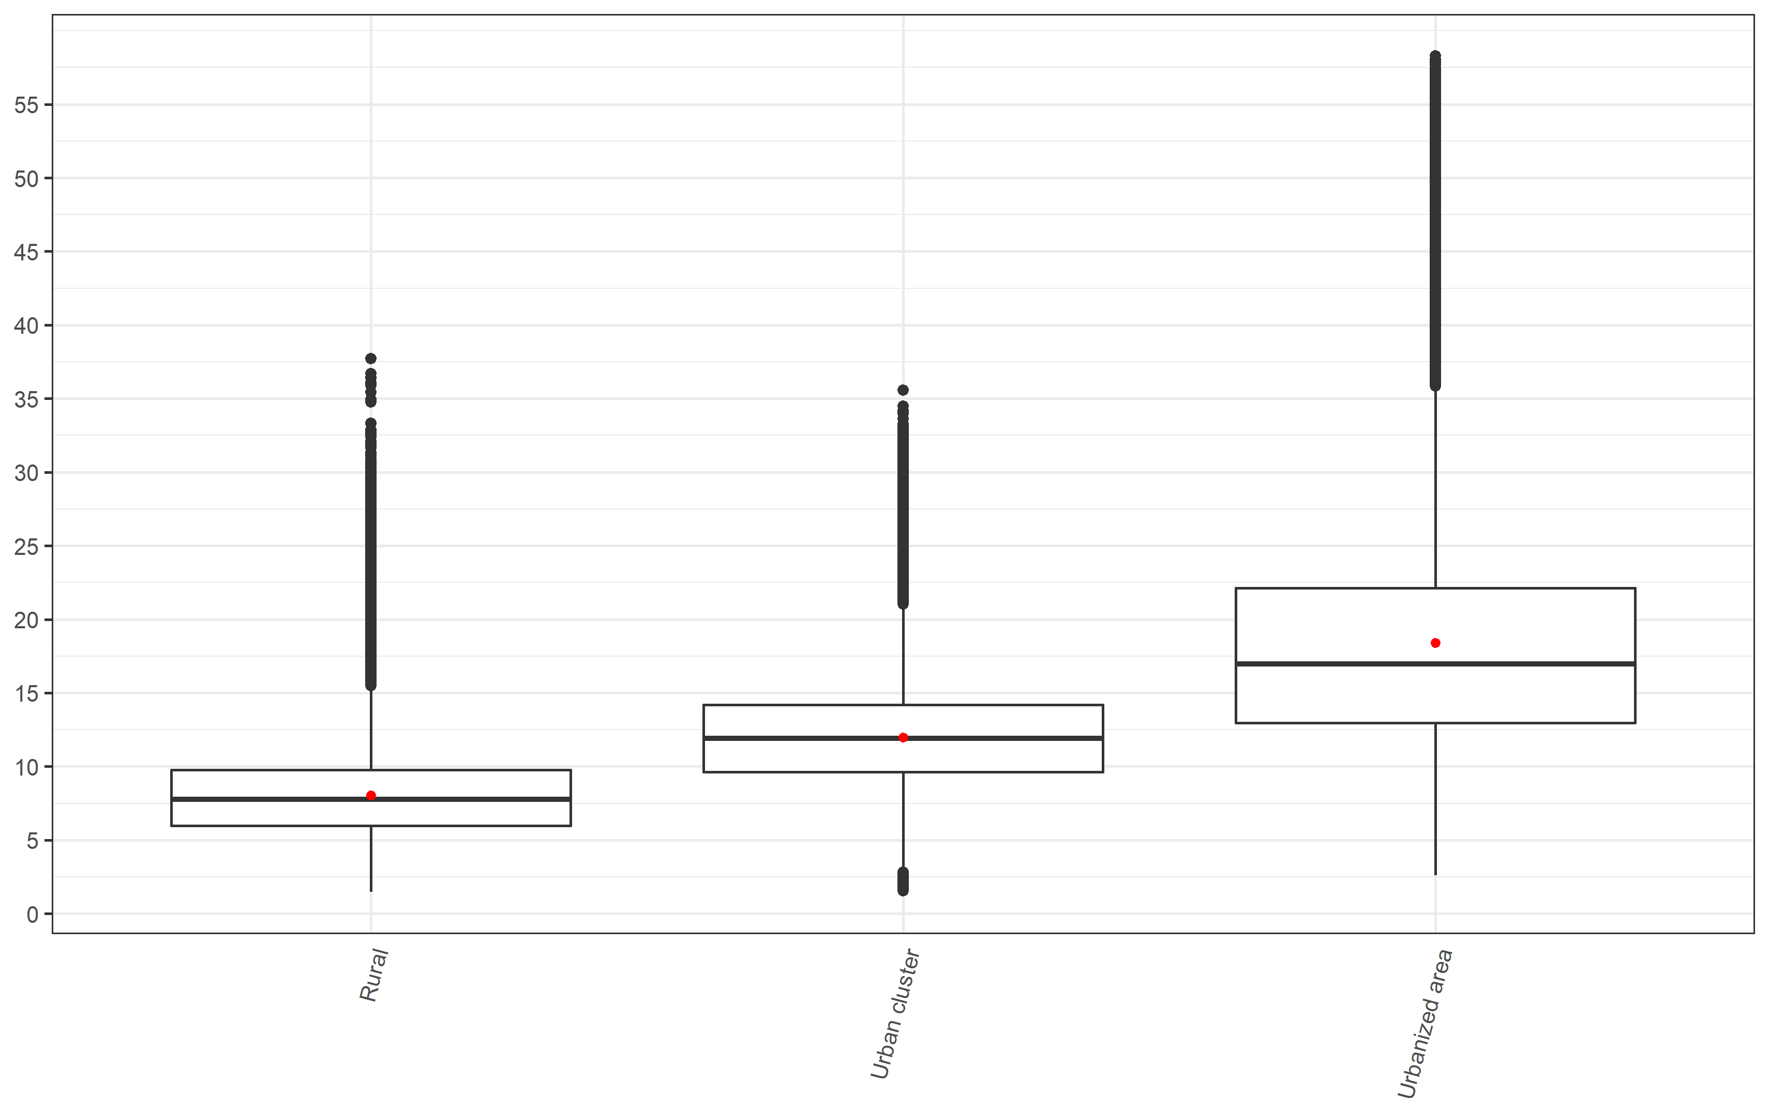

*\*Red dot represents the mean value while the midline represents the median value*

Figure S2: NO2 concentration (ug/m3) by median household income group

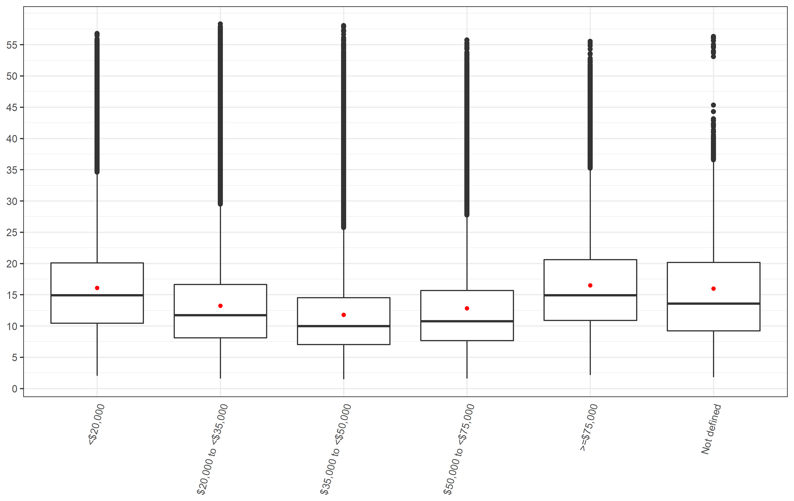

Figure S3: NO2 concentration (ug/m3) by living location stratified into median household income group

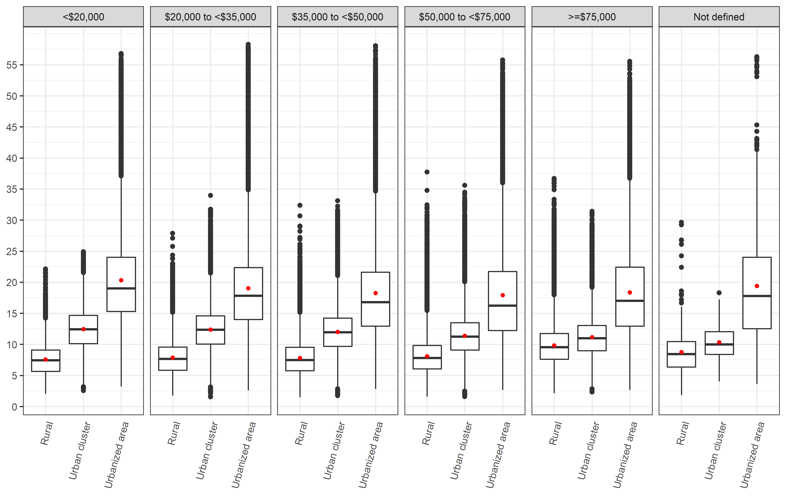

Figure S4: NO2 concentration (ug/m3) by median household income group stratified into living location

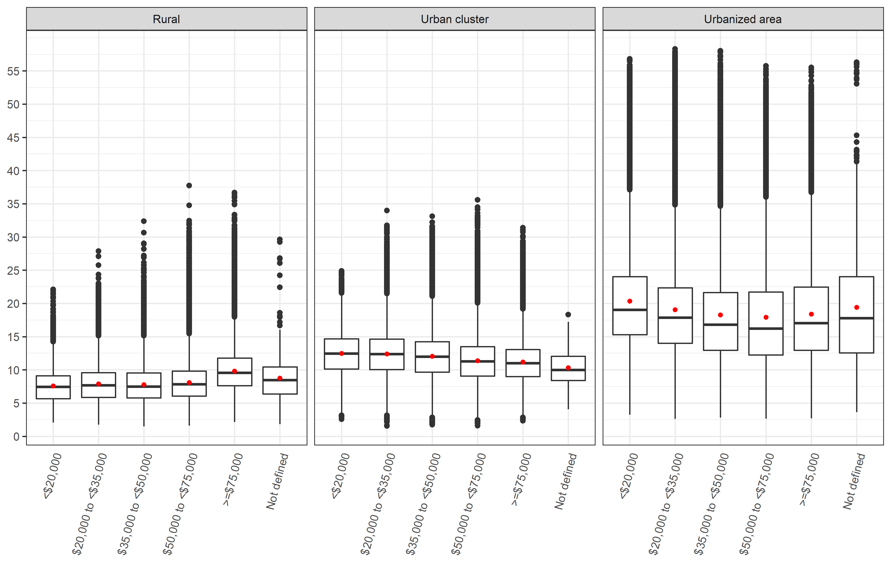

Figure S5: NO2 concentration (ug/m3) by state

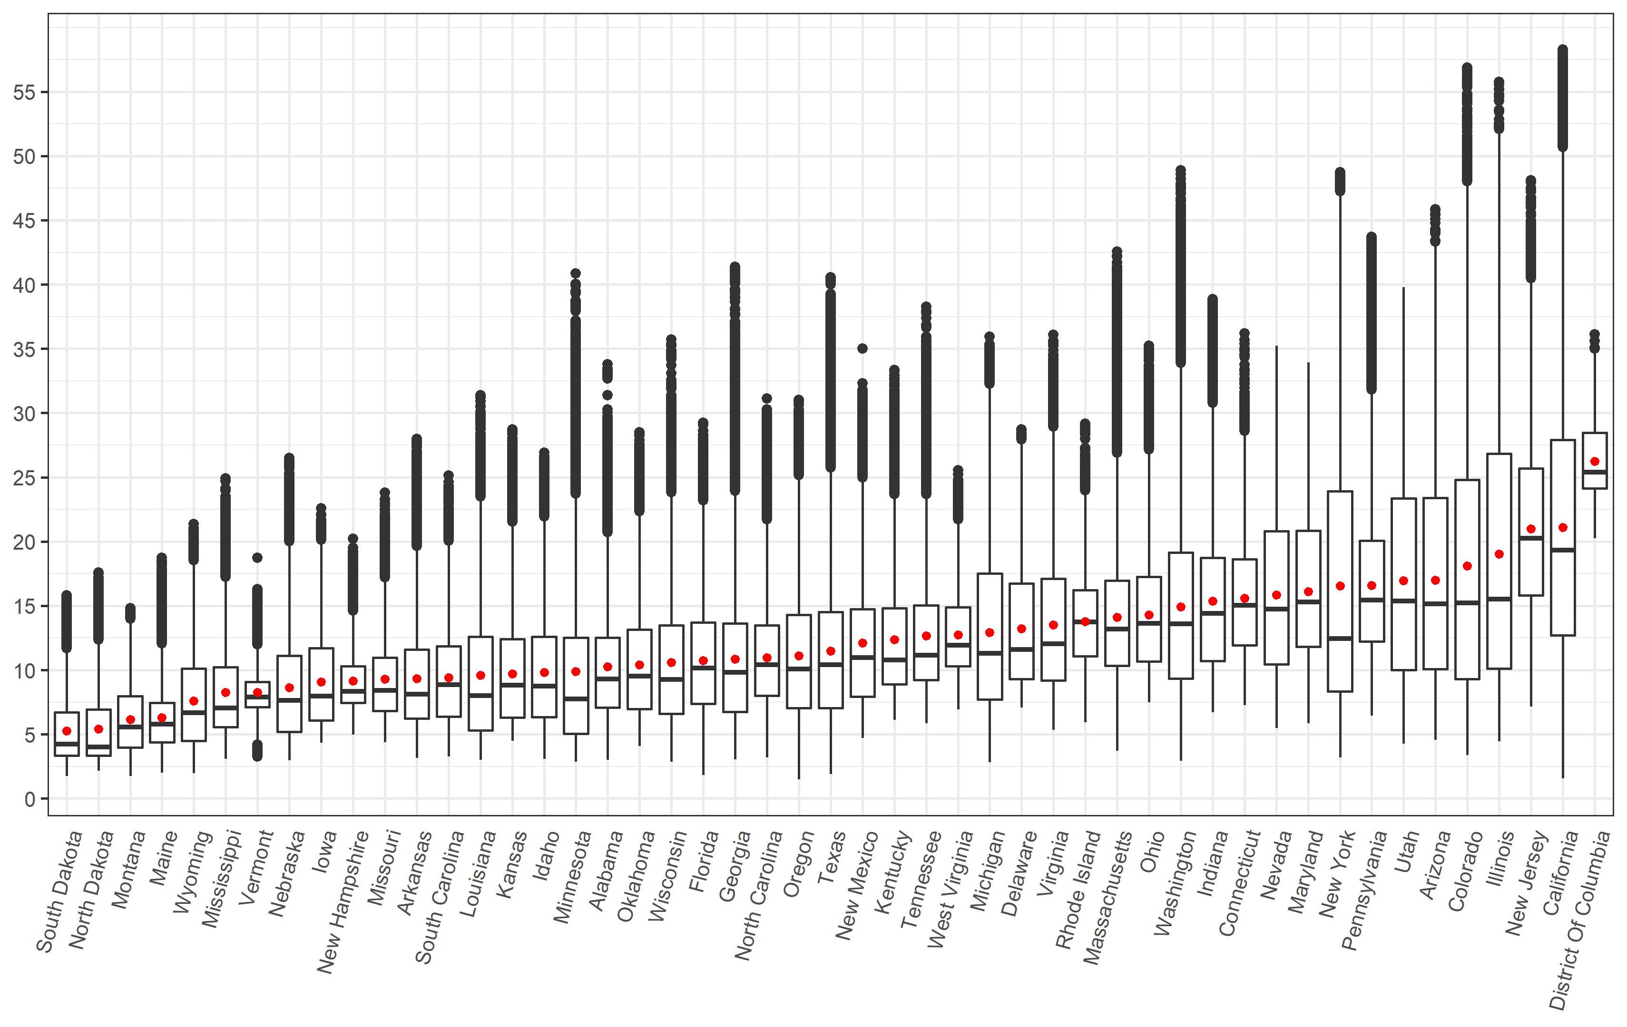

Figure S6: NO2 concentration (ug/m3) by state and median household income group

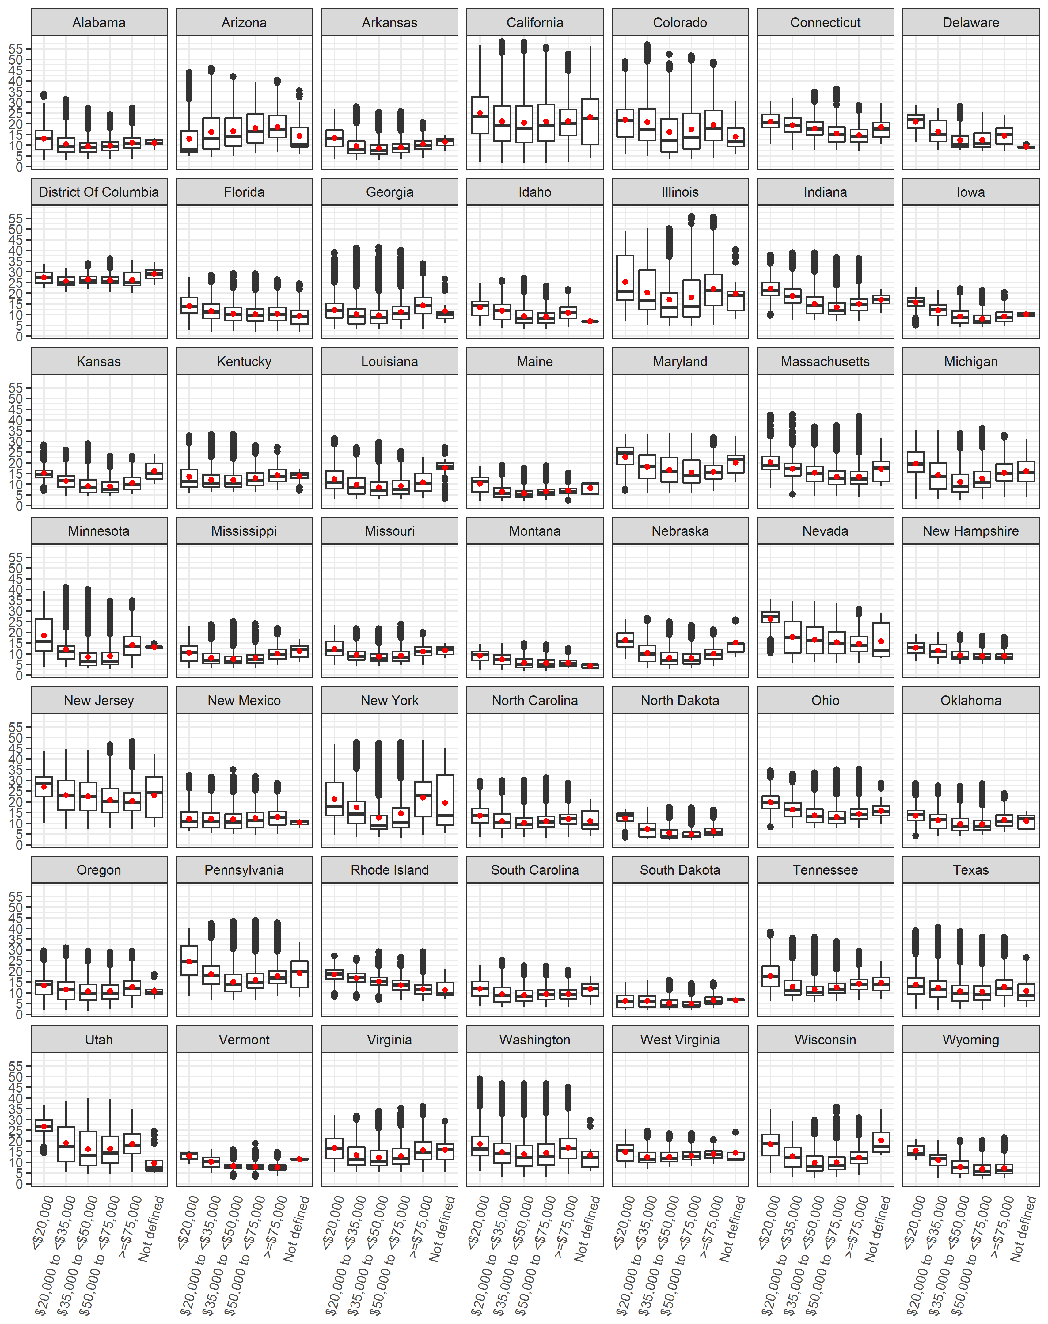

Figure S7: NO2 concentration (ug/m3) by state and living location

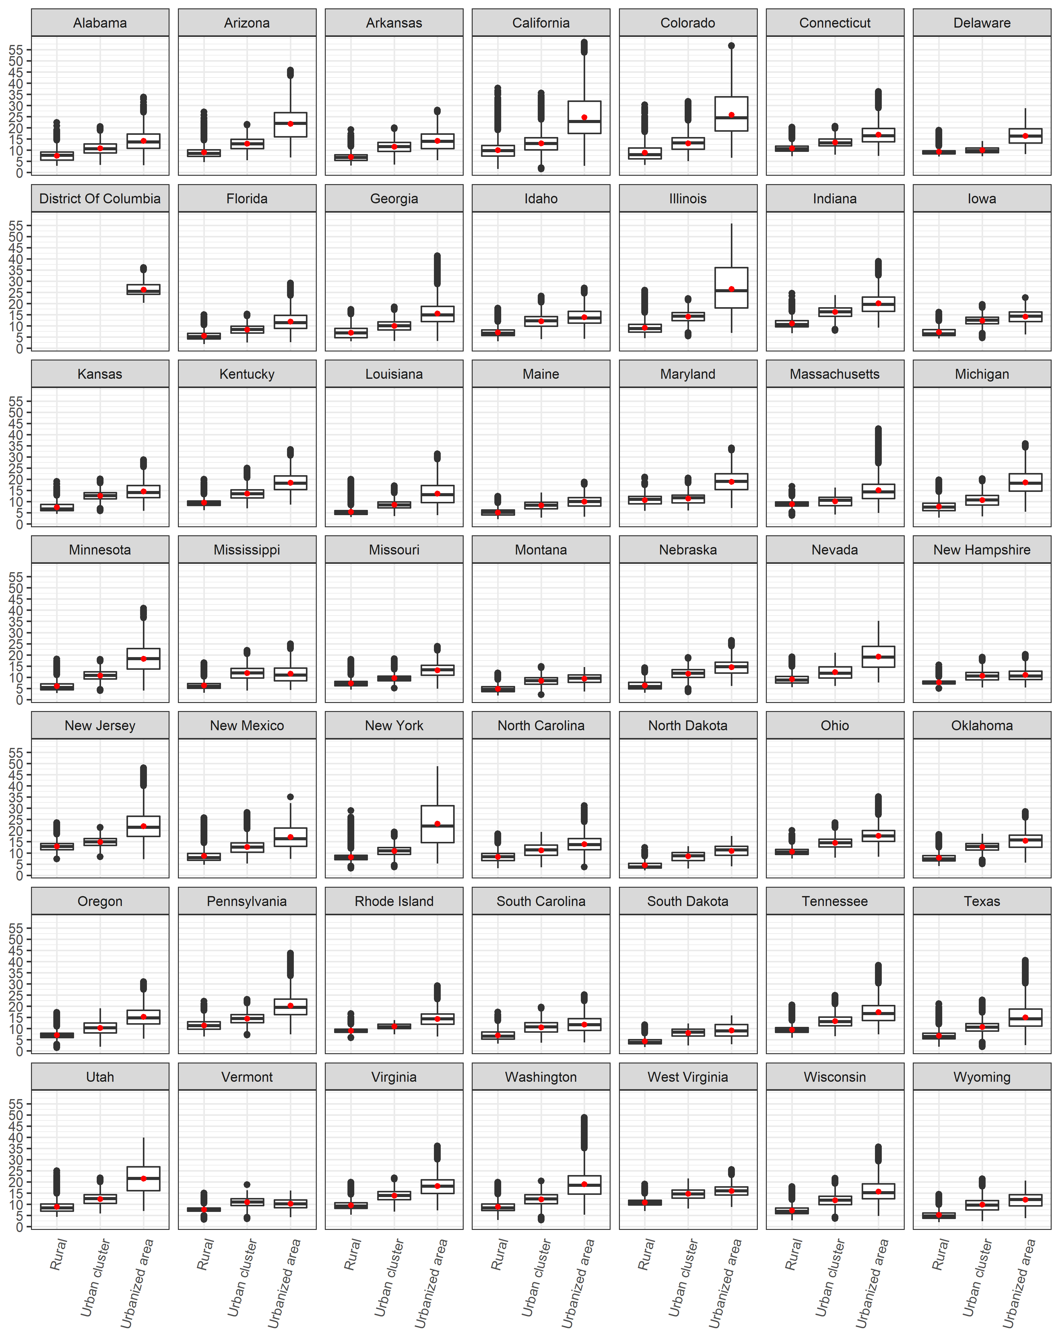

Figure S8: Attributable Fraction by living location

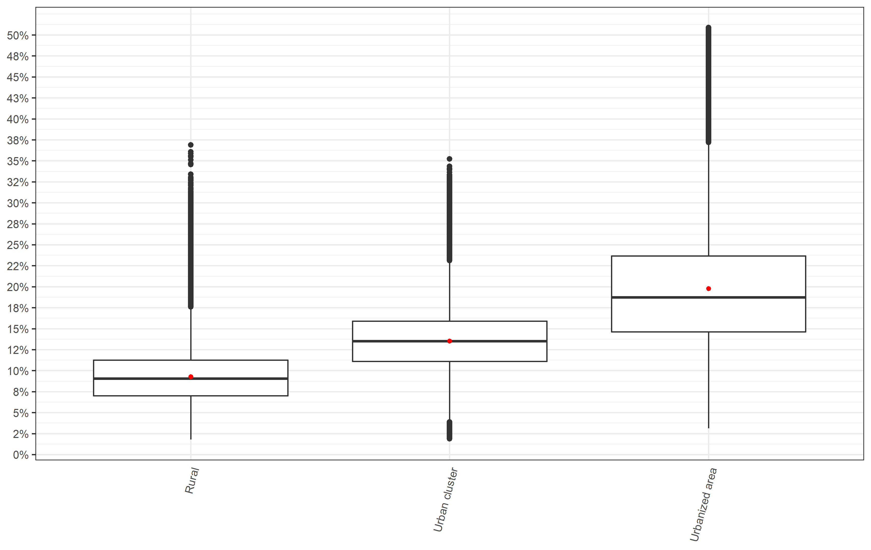

Figure S9: Attributable Fraction by median household income group

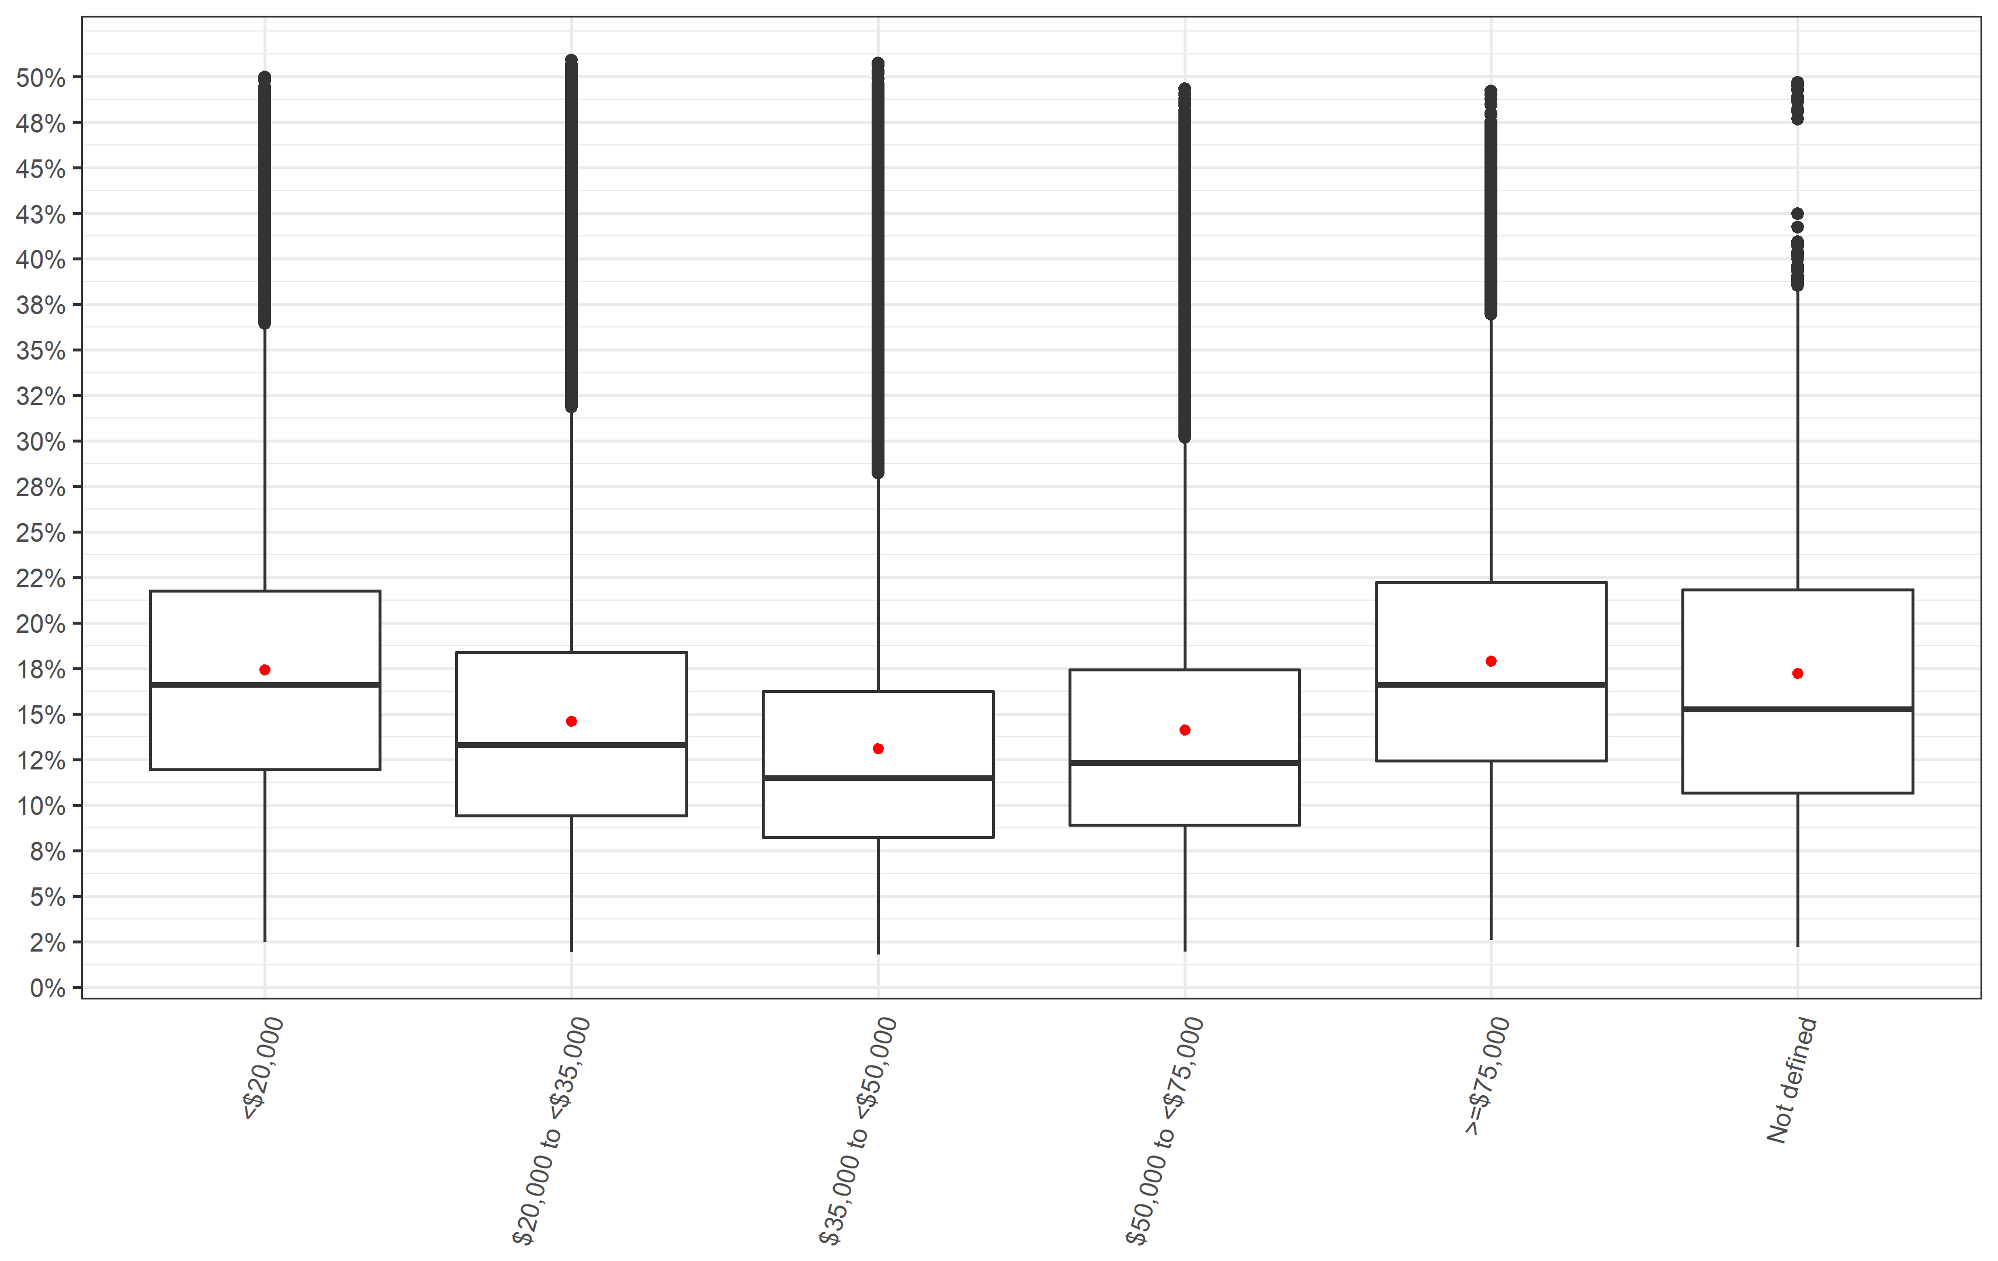

Figure S10: Attributable Fraction by median household income group stratified into living location

